

**Term Project Report**

**COURSE:** CMSE 512 Database and File Security

**STUDENT INFORMATION:** Salahi Erensel 23502460

**PROJECT:** Online Secure Hospital System

**SEMESTER TERM:** 2024- 2025 Spring Semester

**SUPERVISOR:** PROF. DR. ALEXANDER CHEFRANOV

**Outline**

1. Task Formulation
2. Database Schema
3. Algorithm Description
4. Tools used for implementation
5. Developed Program Description
6. User Guide
7. Tests & Results
8. Conclusion
9. References

**1-) Task Formulation**

**Objective:** Develop an online hospital management system providing access to patient information and performs hospital operations while ensuring data confidentiality and integrity.

**System Overview:** Performing hospital operations in a secure way, managing patient records, doctor assignments, appointments, admin tasks in a role-based access control system.

**Primary Goals:**

1. Secure patient data management by integrating appropriate encryption and access controls.
2. Role-Based access control by integrating role-permission architecture.
3. Appointment management between doctor and patient.
4. Medical workflow between doctors.
5. Data security by encryption and digital signatures.

**System Actors**

1. Admin: User management.

* Create user accounts for all system actors.
* Assigning roles to system users.

1. Receptionist: Patient registration.
   * Register new patients to system.
2. Chief Doctor: Managing patient appointment requests.
   * Assigning patient to a curing doctor.
   * Viewing all patients and their medical records.
3. Curing Doctor: Managing patients assigned.
   * Scheduling appointment with assigned patient.
   * Inserting / Updating medical record for the patient after the appointment is completed.
   * Assigning consulting doctor to an assigned patient.
4. Consulting Doctor: Managing patients assigned.
   * Viewing patients assigned and their medical records.
5. Patient: Performing medical requests.
   * Create appointment request
   * Viewing own medical records (not restricted) that curing doctor entered.

**Security Requirements**

1. Authentication and Authorization: All system access requires username and password during login.
2. Role-Based access control: Each user has a role and each page is allowed to the roles in access control matrix.
3. Data protection: Password of users is hashed and stored, medical record data is encrypted and signed by digital signatures and stored.

**Access Control Matrix**

Patient Records Access:

* Curing Doctor: Full Access to assigned patients. (read, write, update)
* Chief Doctor: Read-only
* Patient: View own medical records which are not restricted ones.
* Consulting Doctor: View only assigned patients.

**Functional Requirements**

* User Management: Account creation, role assignment, password management.
* Patient Registration: Patient information capture and storage.
* Medical Record Management: Create, update, and maintain patient medical records.
* Doctor Assignment: System for assigning curing and consulting doctors to patients.
* Appointment Scheduling: Interface for booking and managing patient appointments.
* Consultation Management: Tools for documenting and tracking medical consultations.
* Access Control: Implementation of role-based permissions and access grants.

**Non-Functional Requirements**

* Performance: System responds to user requests in short time.
* Reliability and Availability: System is mostly available 24/7.
* Scalability: System can accommodate up to 1000 registered users
* Security: Password, email, phone, etc. data validations are integrated. Encryption and hashing are also done.

**2-) Database Schema**

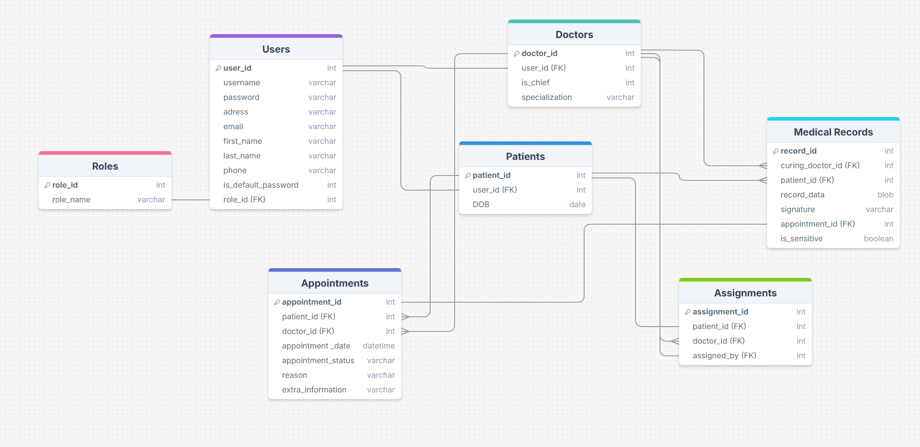**ER Diagram**

**3-) Algorithm Description**

**Patient Data Protection Algorithm:** Input: Patient medical record data, process: apply des encryption to patient data, generate hash of encrypted data using hash function, create digital signature using RSA on the hash, store encrypted data + digital signature, hashing user passwords and storing.

**Data Access Verification Algorithm:** Input: User information + data request, process: authenticate user by username and password, identify user role, check access permission depending on user role, if authorized show data.

**Role-Based Access Control Algorithm:** Input: User login request, identify role, apply the permission matrix, grant / deny access based on role.

**Appointment Scheduling Algorithm:** Input: Patient appointment request, send appointment to chief doctor, chief doctor assigns to curing doctor, curing doctor schedules the appointment date and time.

**Doctor Assignment Algorithm:** Input: Chief doctor assigns curing doctor to patient, chief doctor authorization is checked, assignment is created, cure doctor is granted to see assigned patient records.

**4-) Tools used for implementation**

1. Microsoft Visual Studio 2022 Community. Download link: <https://visualstudio.microsoft.com/tr/vs/community/> .Used for development environment as IDE.
2. Blazor Server components 🡪 Used for page development and data binding.
3. SQLite as database for data storage and operations.
4. .NET & C#🡪 For the development of application. Download link: <https://dotnet.microsoft.com/en-us/download>
5. Mudblazor for components on the page. <https://mudblazor.com/>
6. DBeaver to see database data and tables. Download link: <https://dbeaver.io/>
7. .NET Nuget Package Libraries for encryption, hash functions, RSA, digital signatures. Can be downloaded from Visual Studio to project.
8. DrawSQL to draw ER Diagram. <https://drawsql.app/>
9. Github for version control <https://github.com/>

**5-) Developed Program Description**

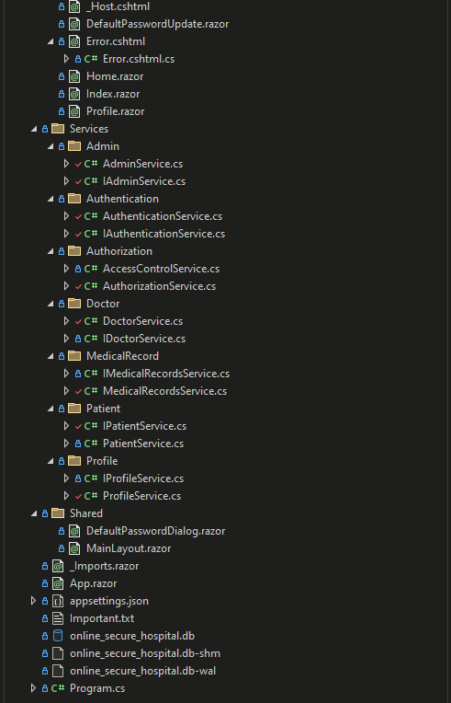**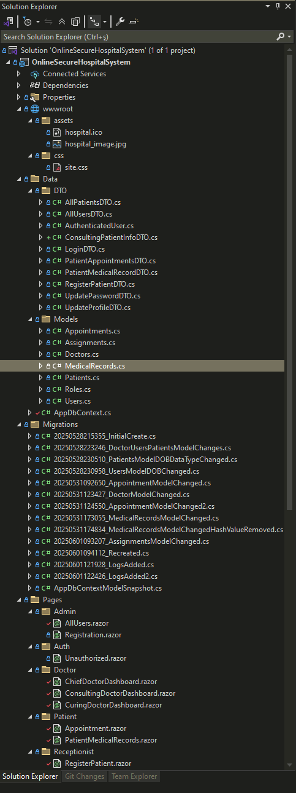Folder Structure**

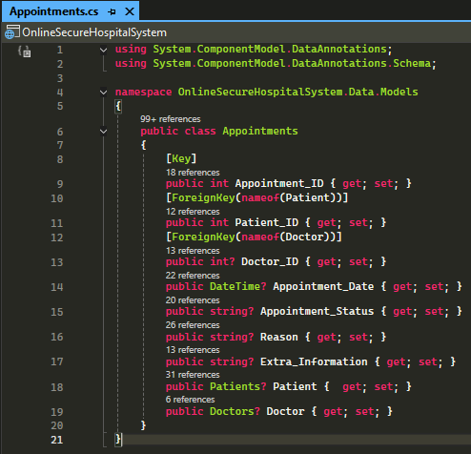**Appointments Model for DB Table** **Assignments Model for DB Table**

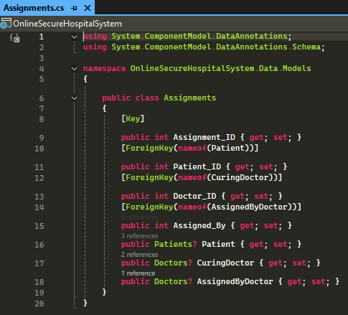

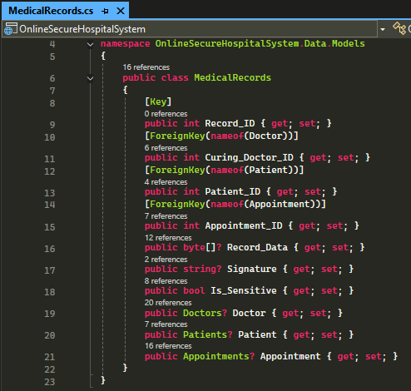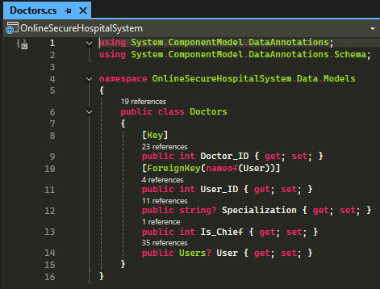**Doctors Model for DB Table** **Medical Records Model for DB Table**

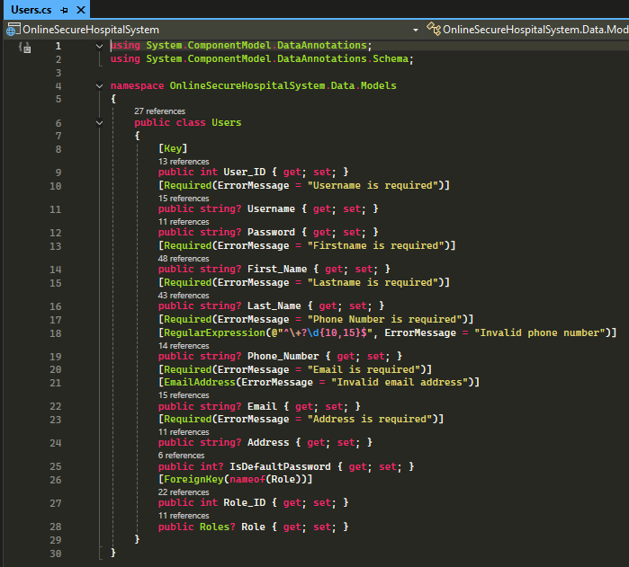**Patients Model for DB Table** **Users Model for DB Table**

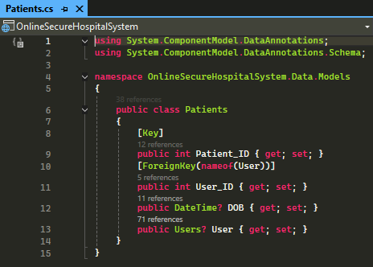

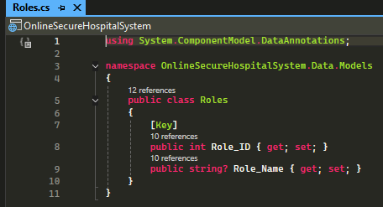**Roles Model for DB Table**

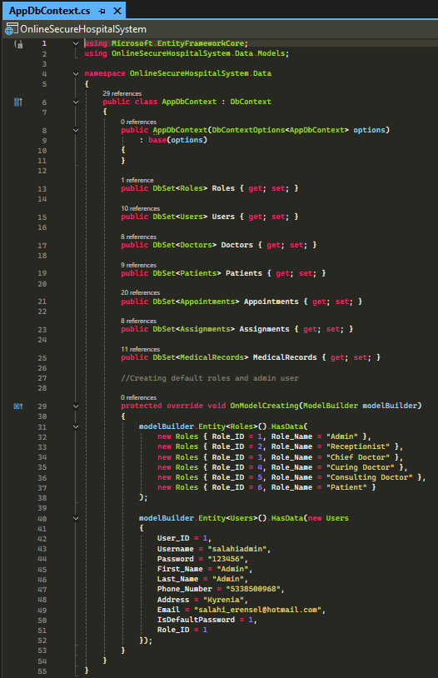AppDbContext uses the models above to create the tables in database and used also for getting data from database. A default user is created as admin role to access the system as first user.

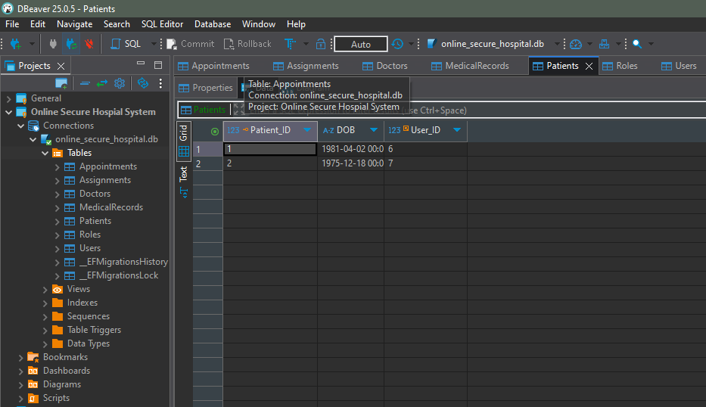**Db Tables**

**MainLayout Component**

Main layout is inherited to all the pages in the system and includes overall

Layout items like sidebar. The menu items are visible to users depending on the user roles as can be seen on the image below. In the mobile view, an icon to open the menu is visible.

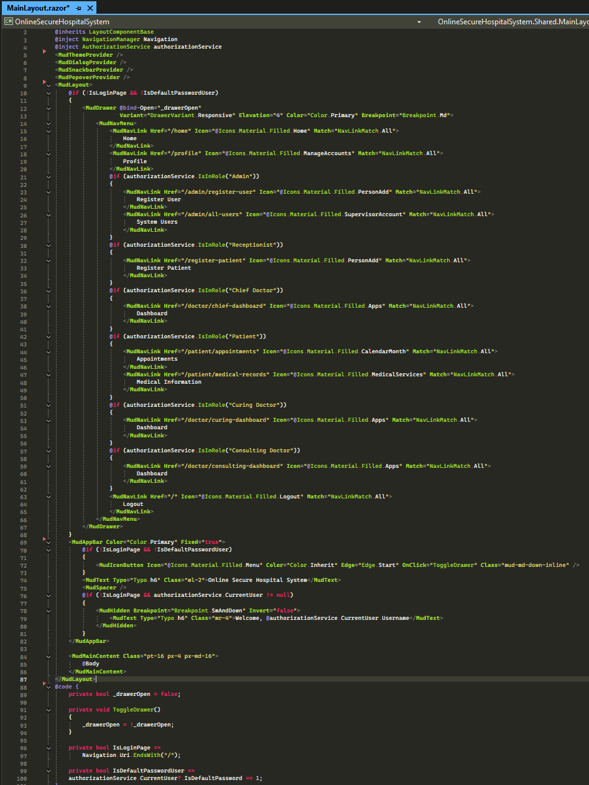

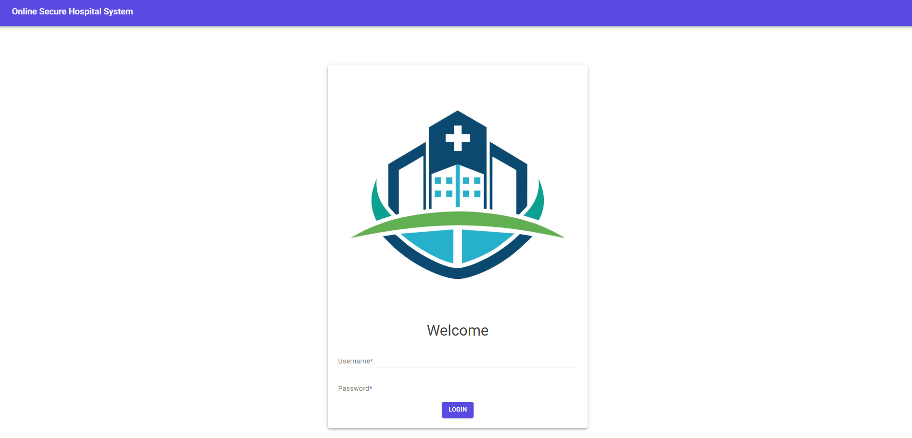Default Page of system is login page.

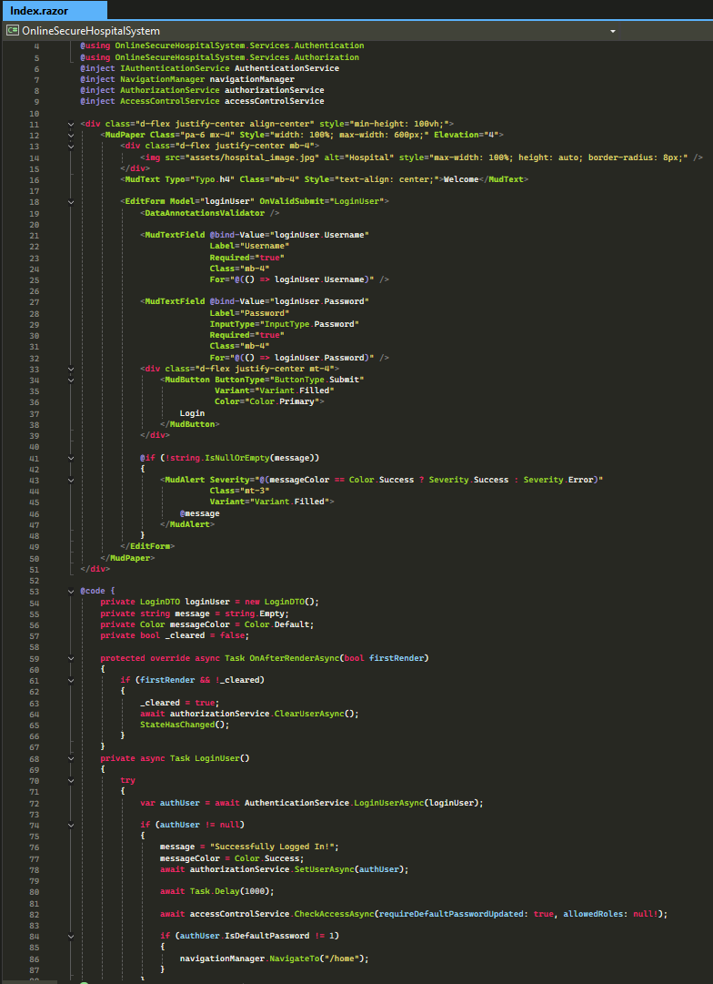

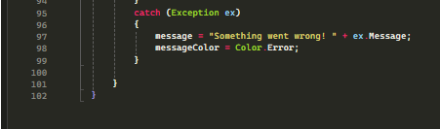Users enter the username and password to login the system. Password is hashed and compared with the hashed password of user in database. If both username and password matches, user is redirected /home route which is home page and is accessible for all users who logged in to system. If not logged in users tries to access this page, they will be redirected to unauthorized page. For login operation, AuthenticationService and AccessControlService methods are used.

**Authentication Service**

Includes methods for Logging the user in, UpdateUserPassword, RegisterPatient, GetUserById methods that are used in application.

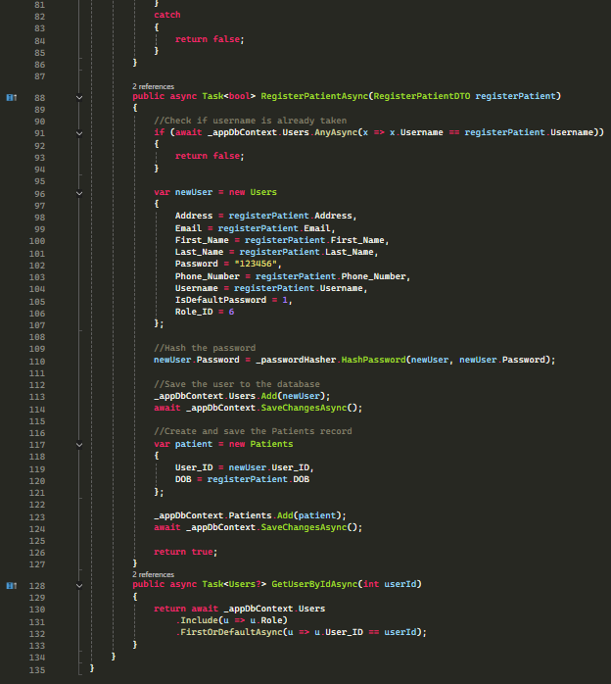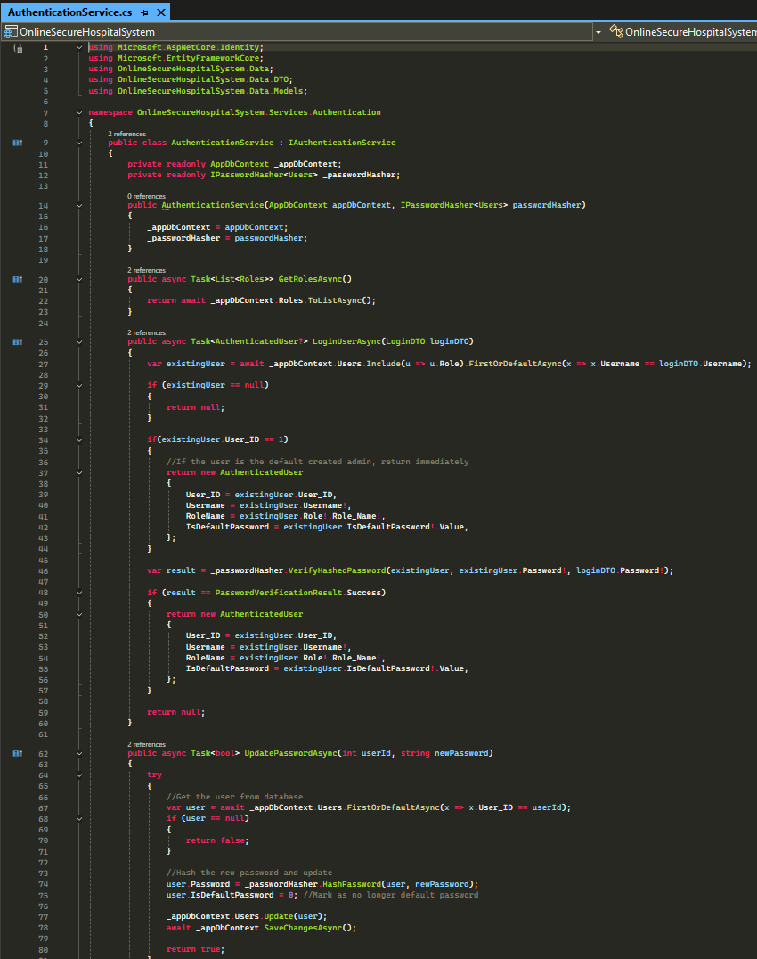

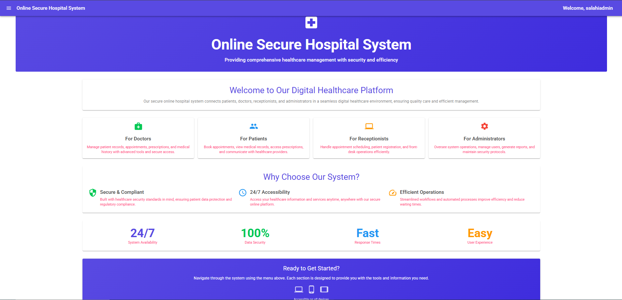**Home Page**

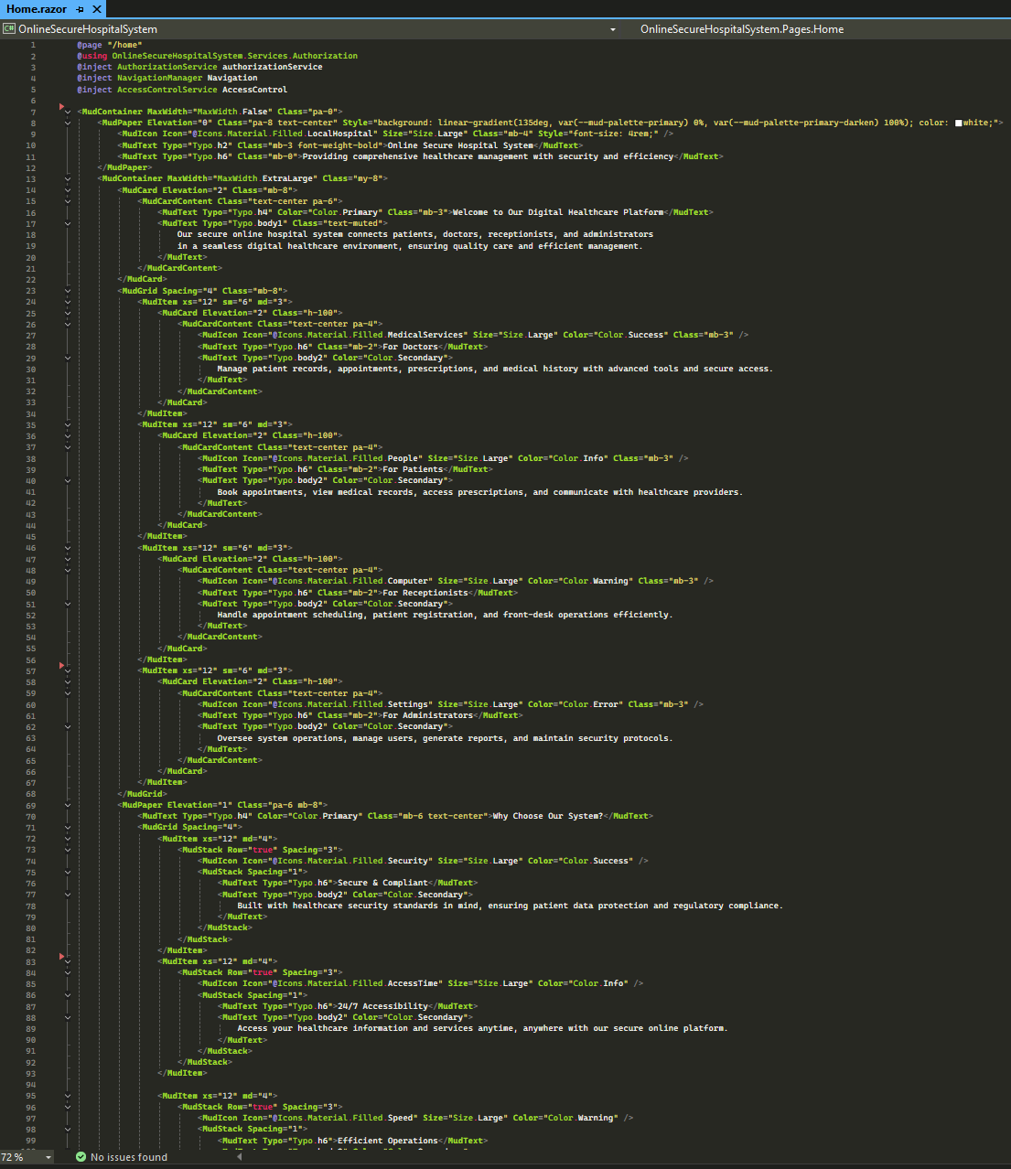

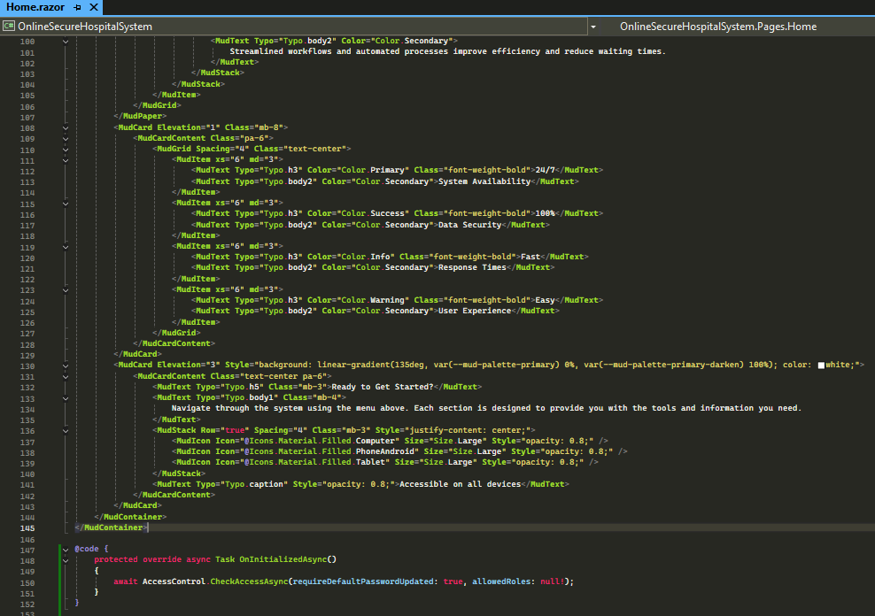

Home page is accessible after successfull login for every user, if tried to reach home page (/home) before login, users are redirected to unauthorized page.

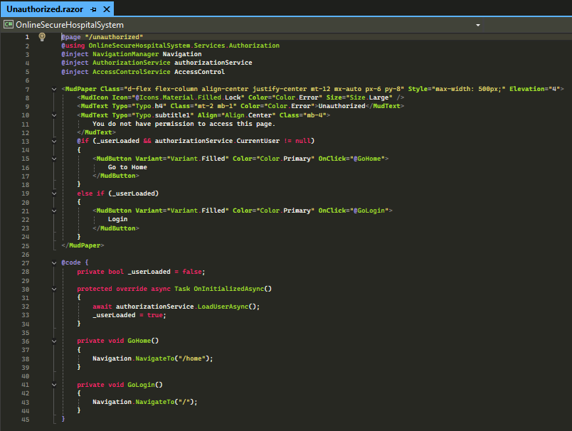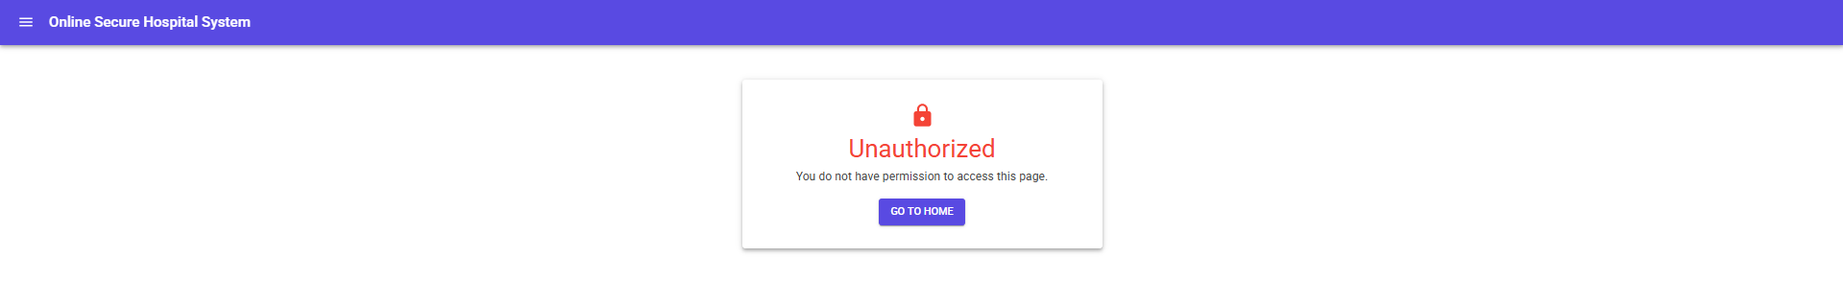**Unauthorized Page**

**Profile 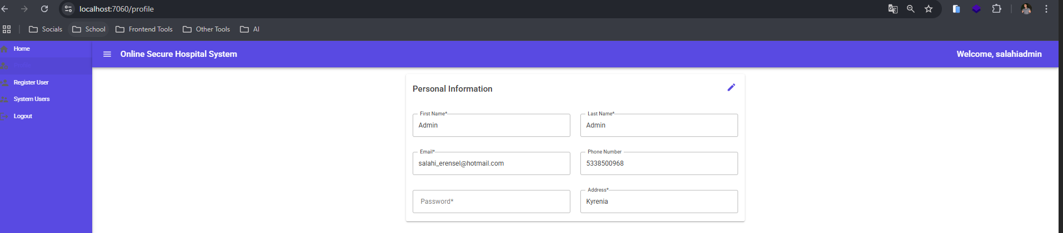Page**

All authenticated users can reach to /profile page to view their information or update personal information including password. If user is a patient, also the patient age is calculated and showed in this page.

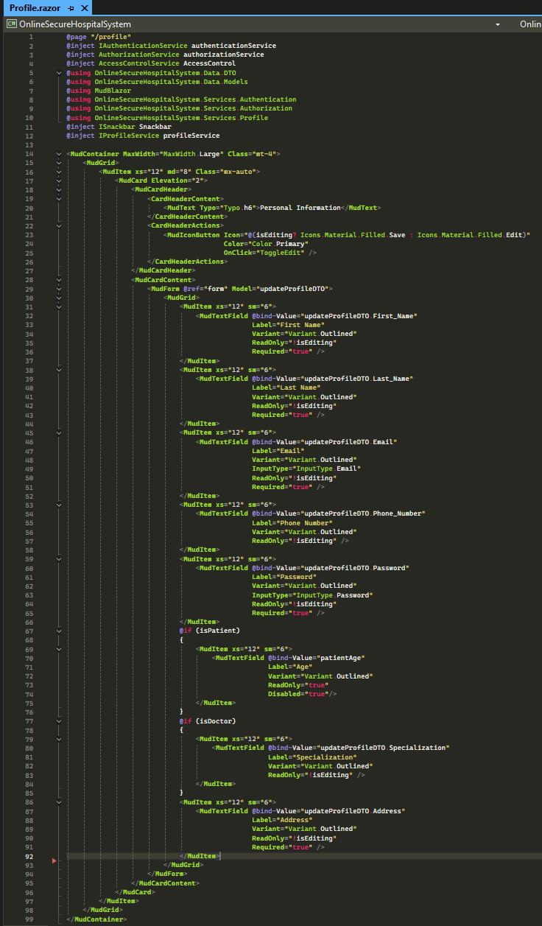

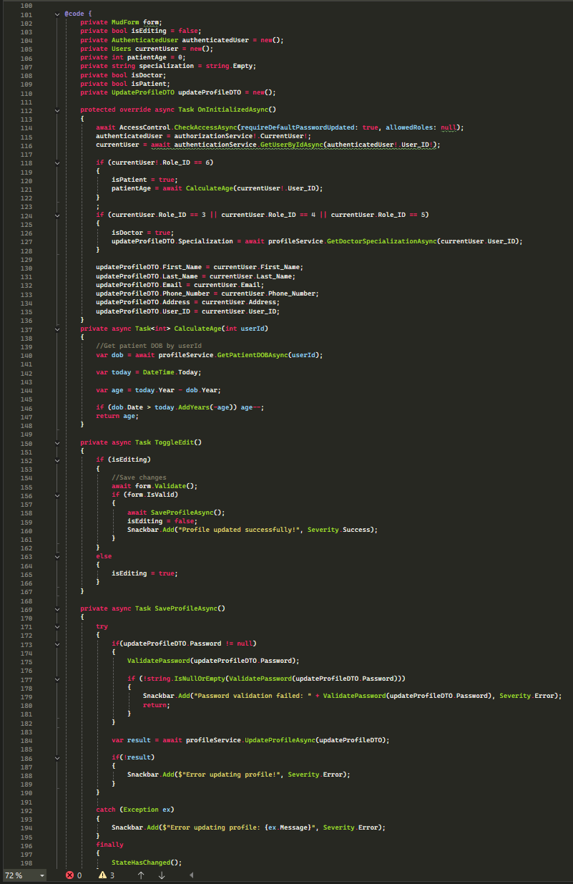

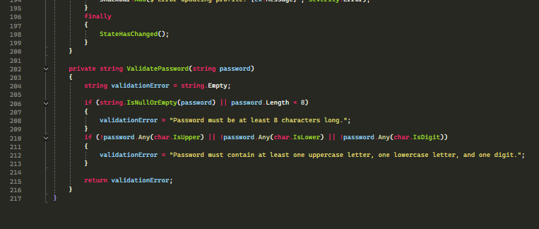

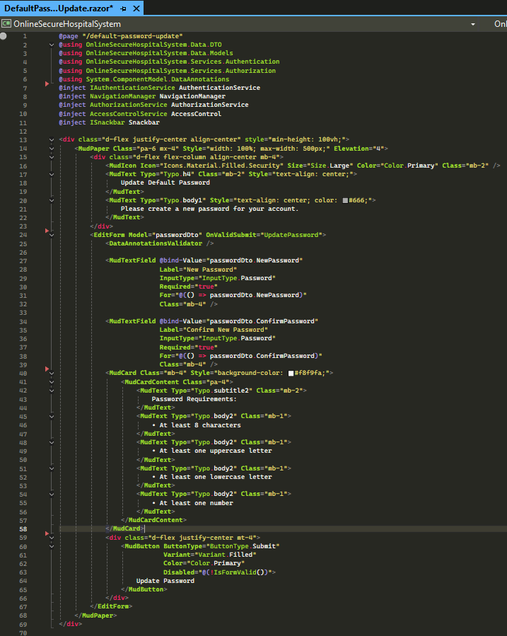**DefaultPasswordUpdatePage**When users are registered to system, they are assigned a default password as “123456”. When they login to system, system checks if they are still using default password, if yes, system forces users to change the default password and cannot do any operation in the system before changing the password.

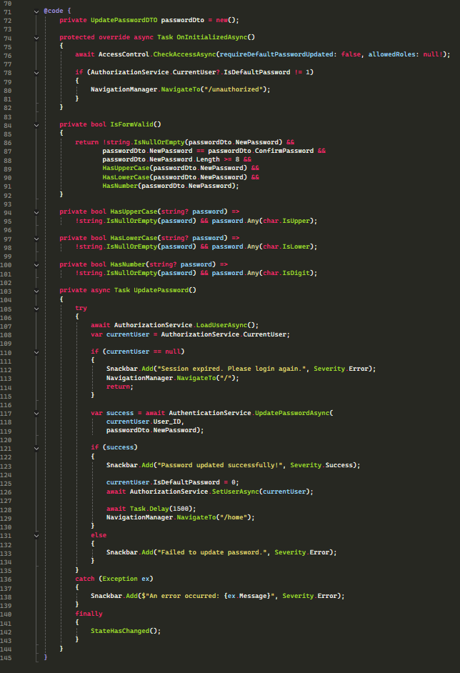

**Register New User Page Admin**

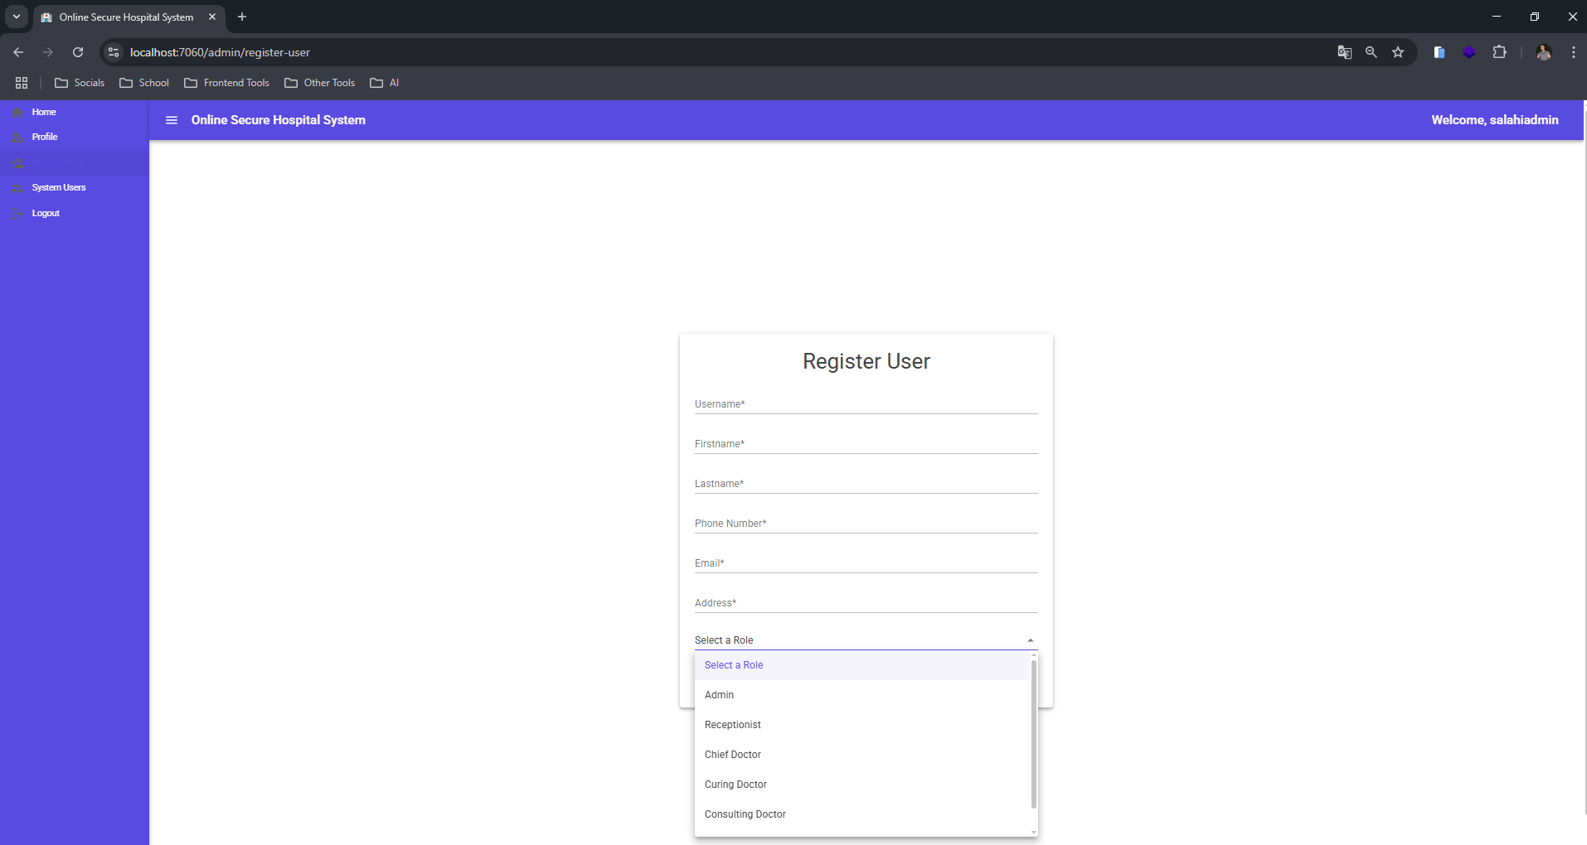Admin uses this page to register users to system. When the page is loading, logged in user role is checked and if admin, menu option and the route /admin/register-user is available to the user. AdminService methods are used in this page.

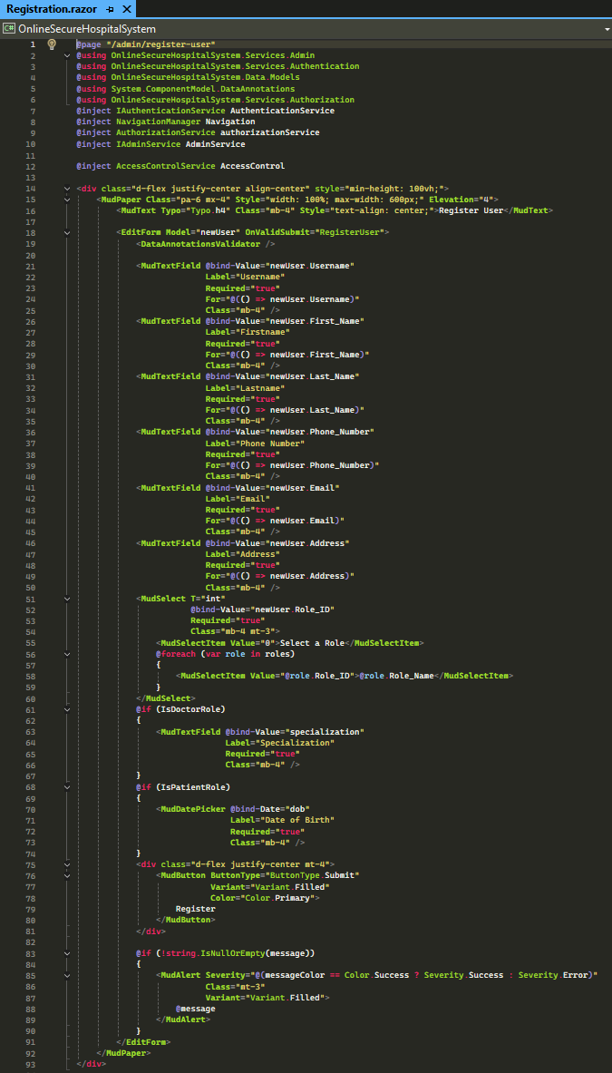

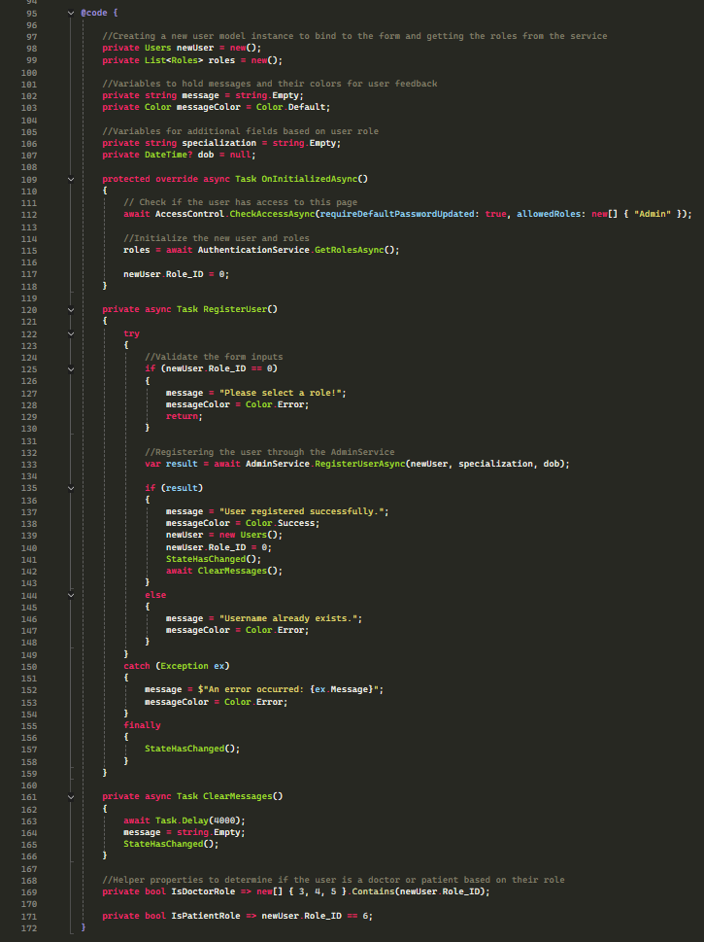

**All Sytem Users Page Admin**

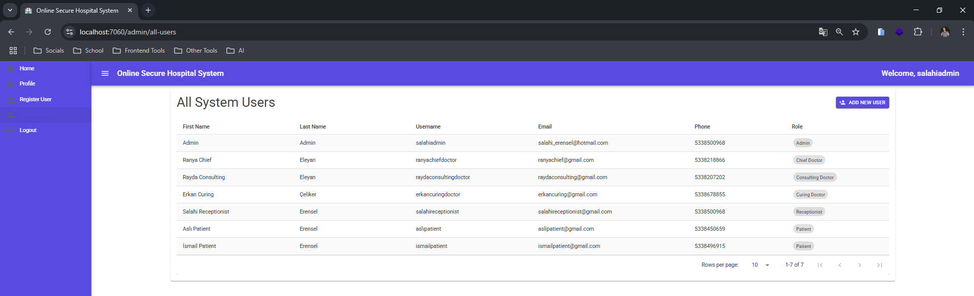Admin uses this page to view all users in system. When the page is loading, logged in user role is checked and if admin, menu option and the route /admin/all-users is available to the user. AdminService methods are used in this page. Details of the system users are shown.

When add new user button is clicked, user is redirected to Register User page.

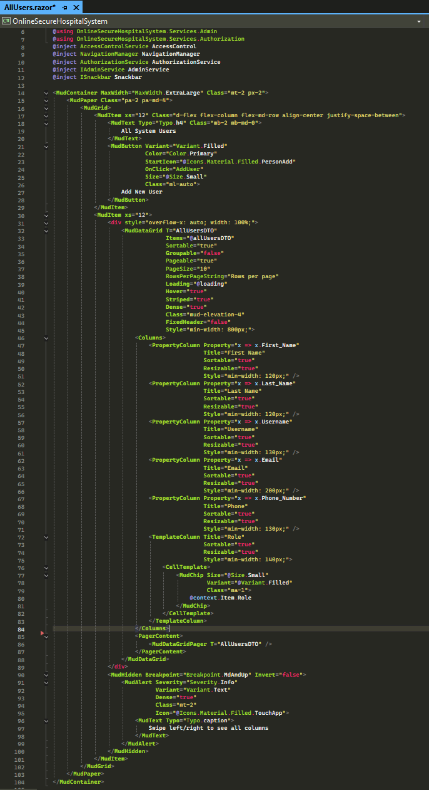

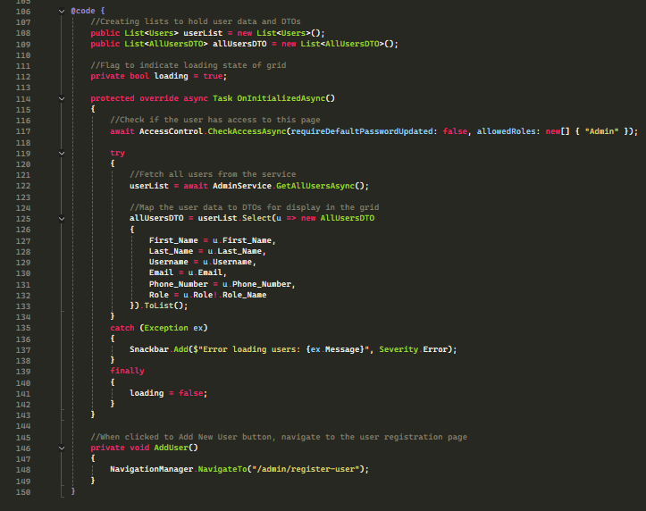

**Register New Patient Page Receptionist**

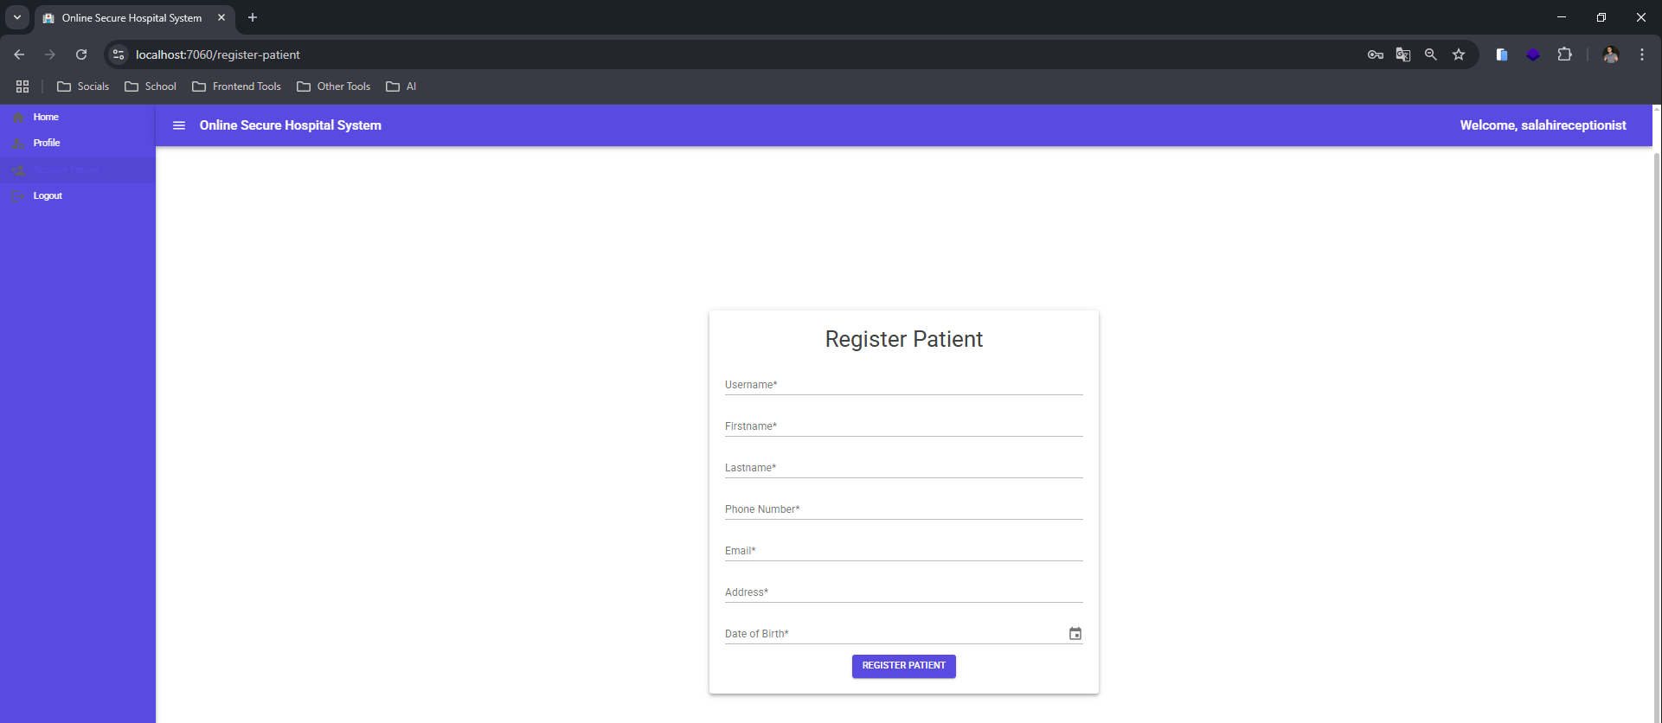Receptionist uses this page to register new patient to the system. When the page is loading, logged in user role is checked and if patient role, menu option and the route /register-patient is available to the user. AuthenticationService methods are used in this page.

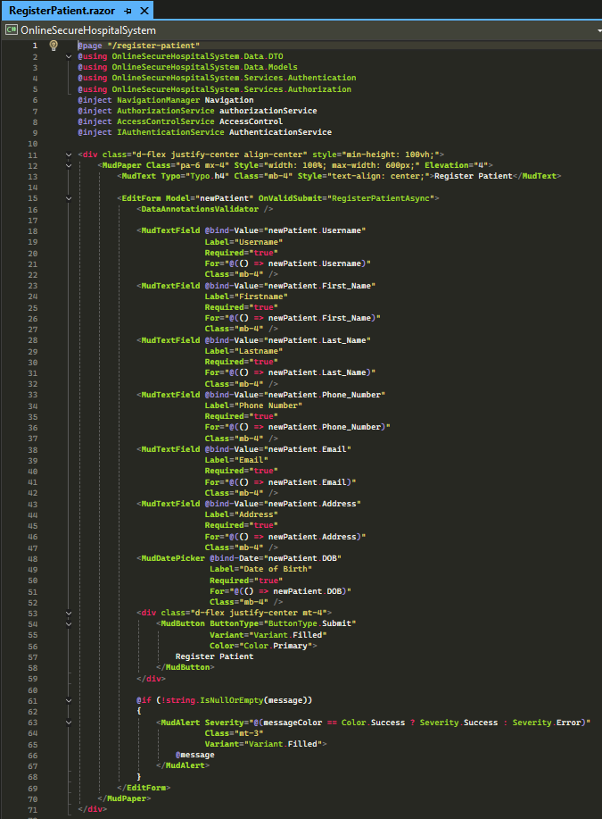

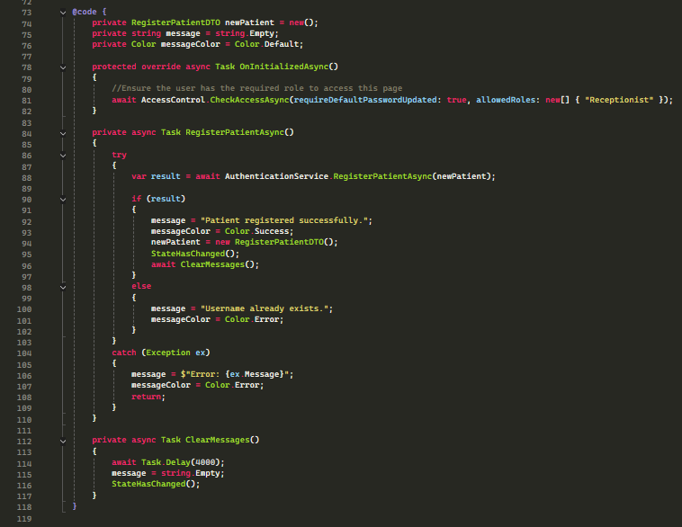

**Appointments Page Patient**

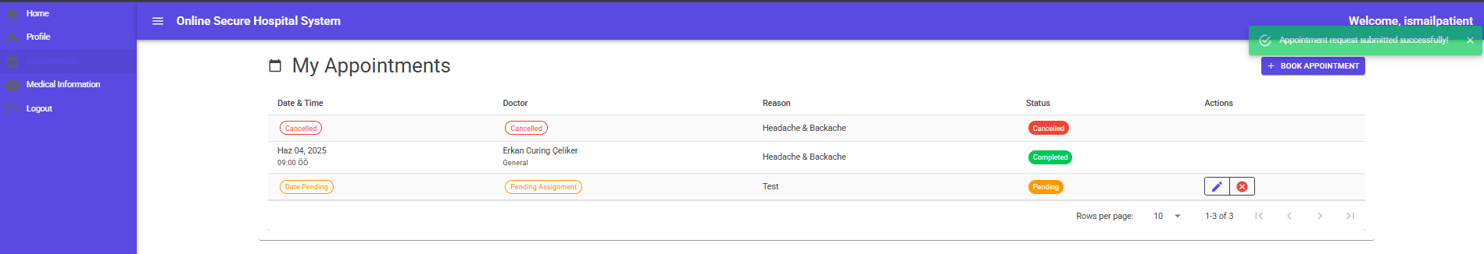Patient uses this page to view all appointments. When the page is loading, logged in user role is checked and if patient, menu option and the route /patient/appointments is available to the user. PatientService methods are used in this page. Details of the appointments are also shown. If the appointment is in pending status, patient can cancel or edit the reason & extra information parts of appointment. When book new appointment button is clicked, create new appointment modal is opened.

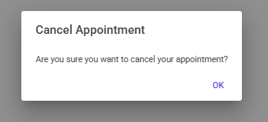

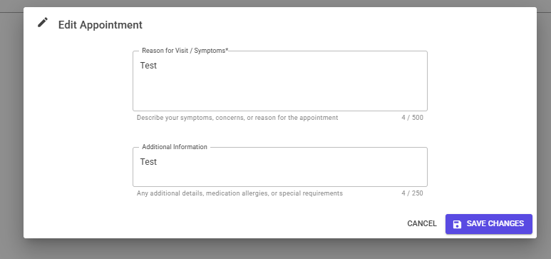

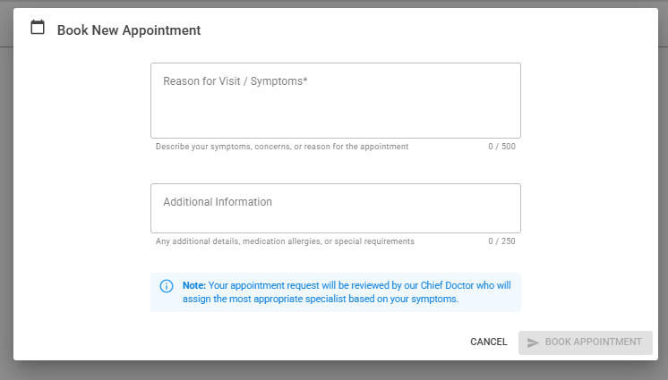

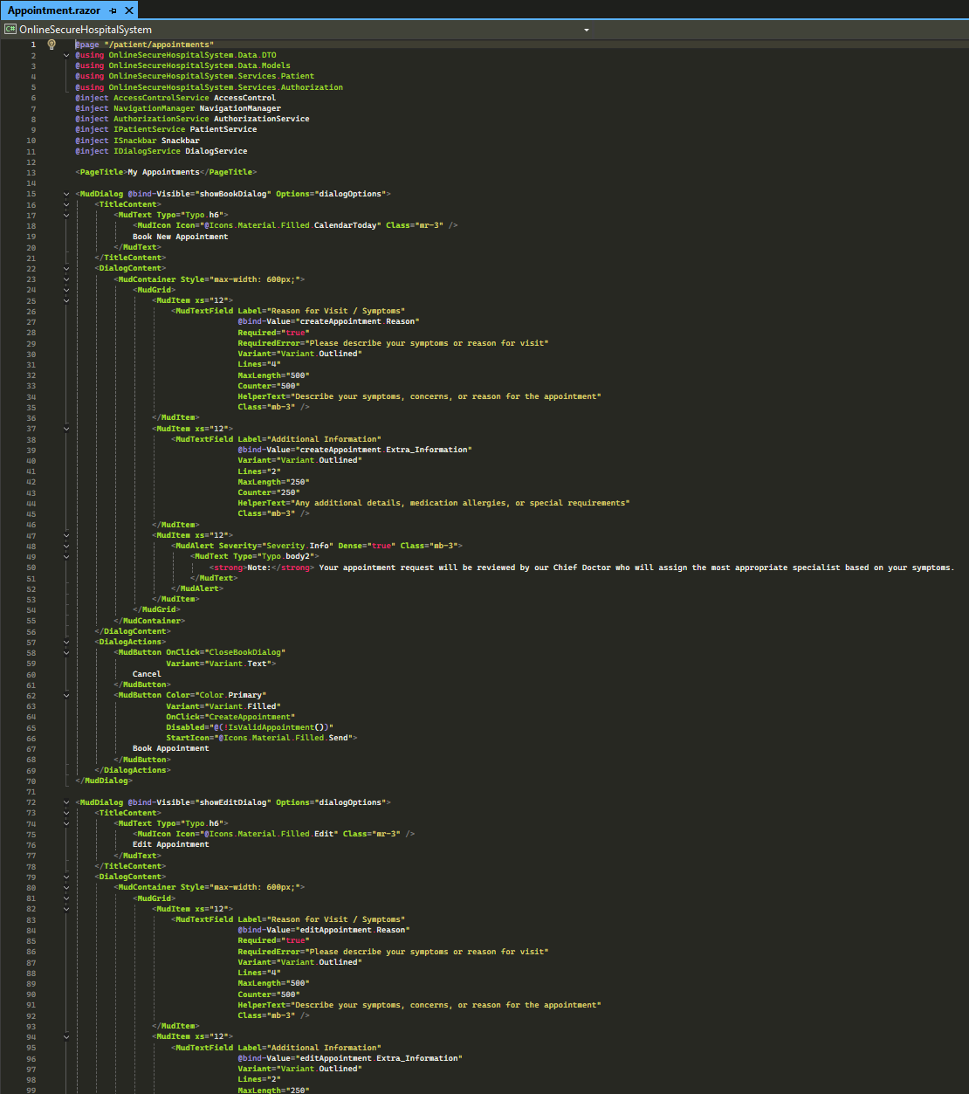

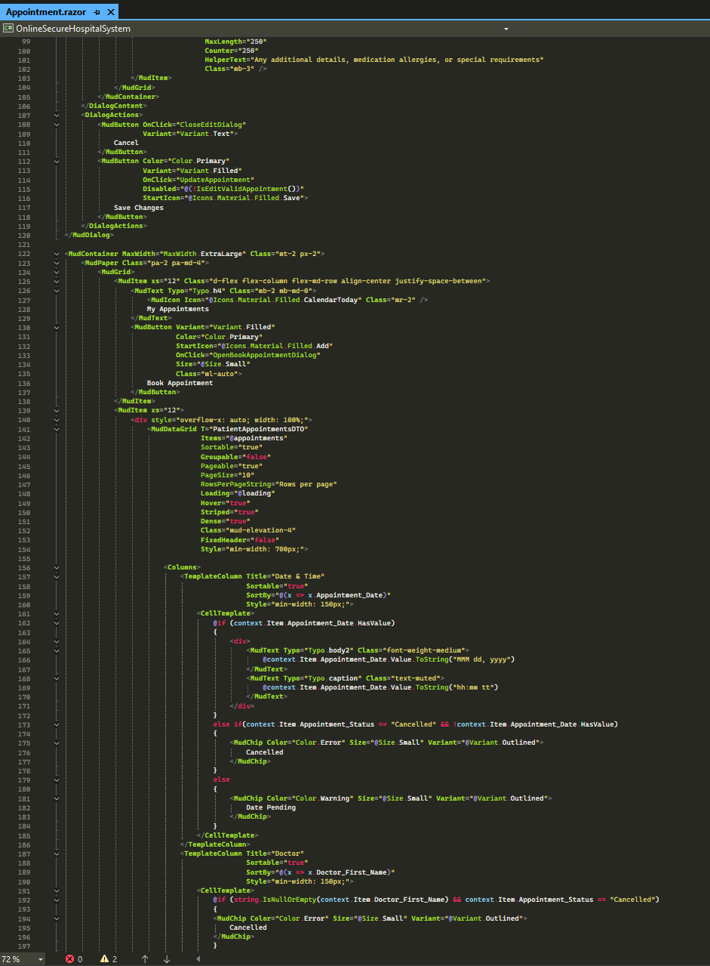

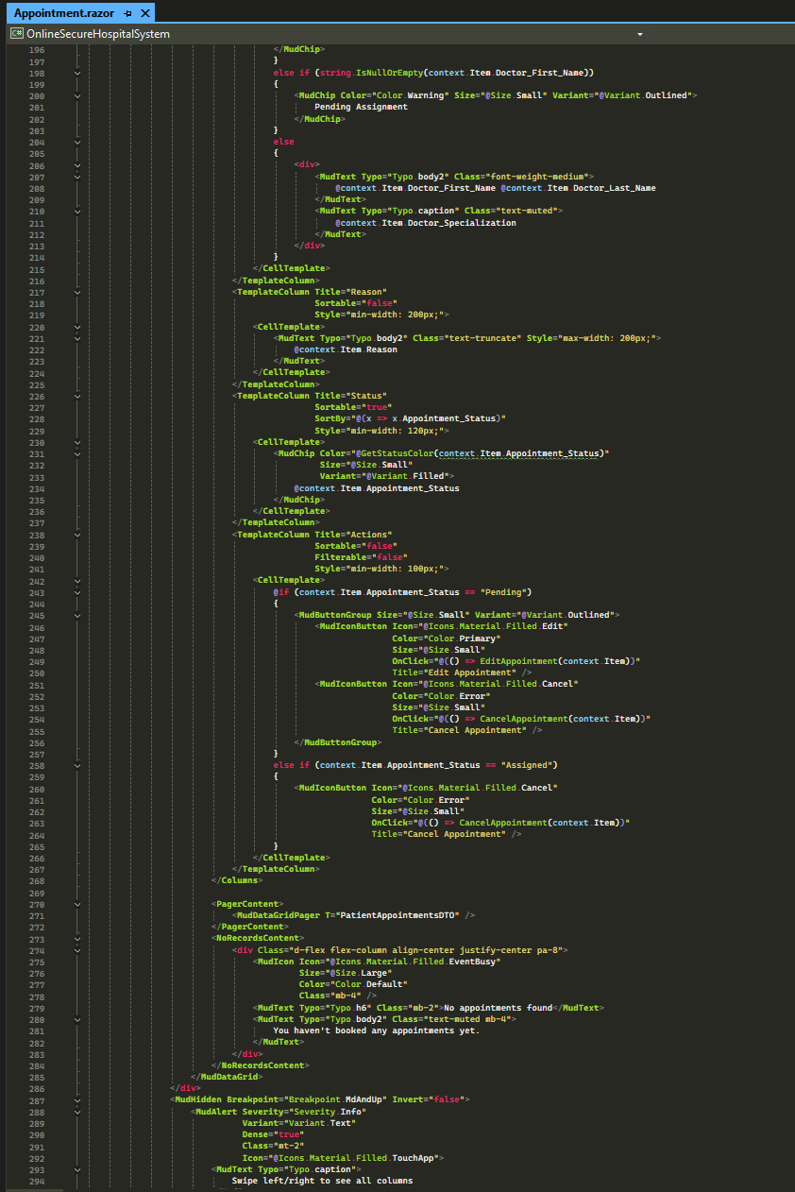

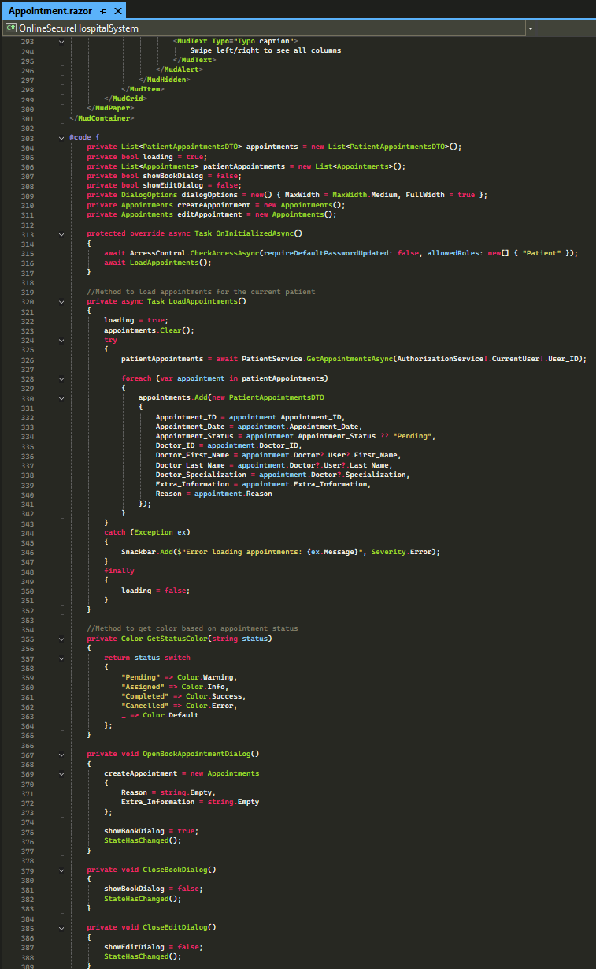

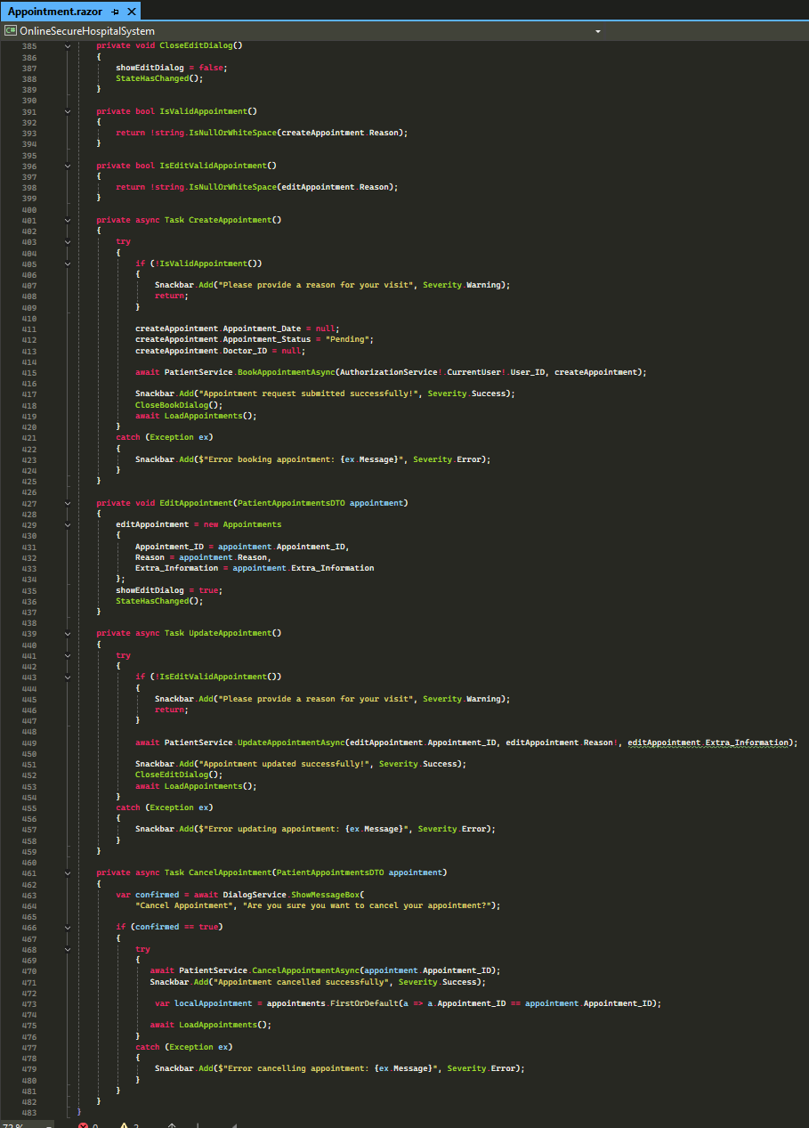

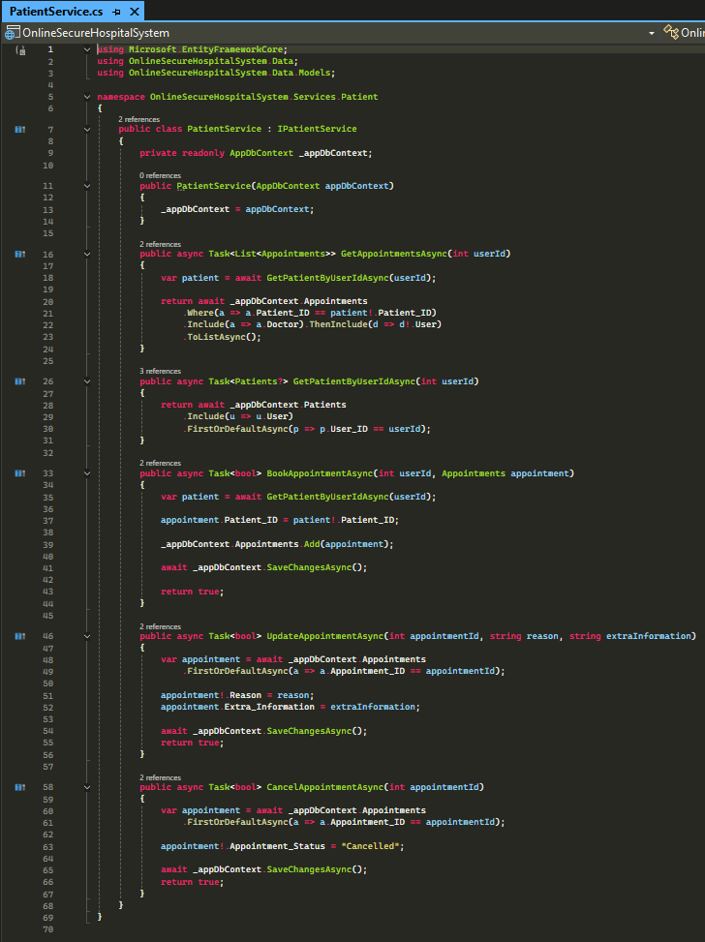

**MedicalRecordsPage Patient**

Patients can see their medical records that the curing doctor entered after the appointment. Some records are marked as sensitive by curing doctor so patient cannot see. When the page is loading, logged in user role is checked and if patient, menu option and the route /patient/ medical-records is available to the user. MedicalRecordService methods are used in this page.

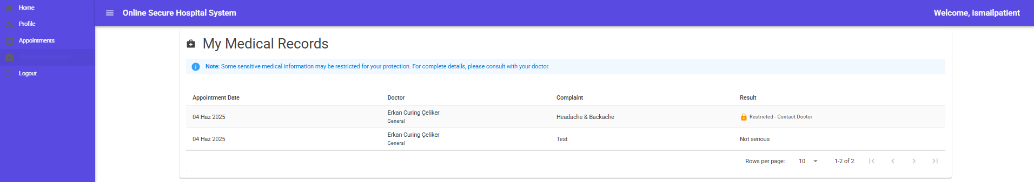As medical record data is DES encrypted and digitally signatures, decryption is integrated to show the data to patient.

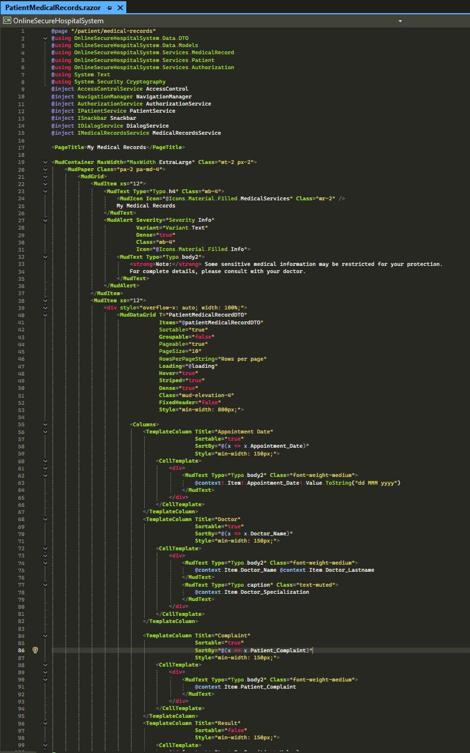

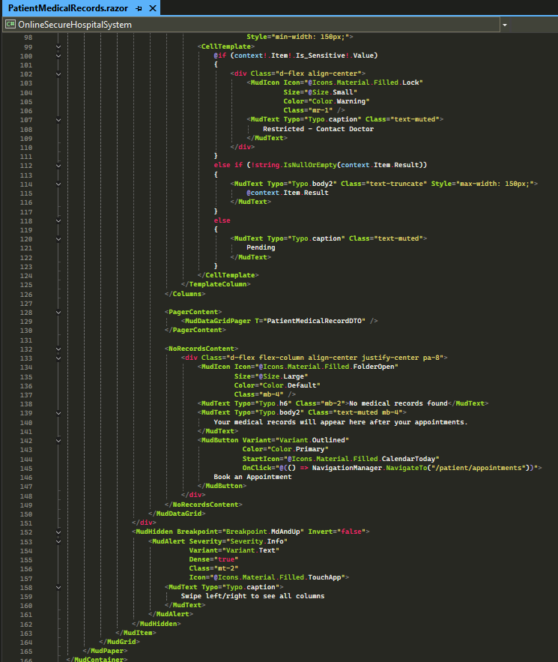

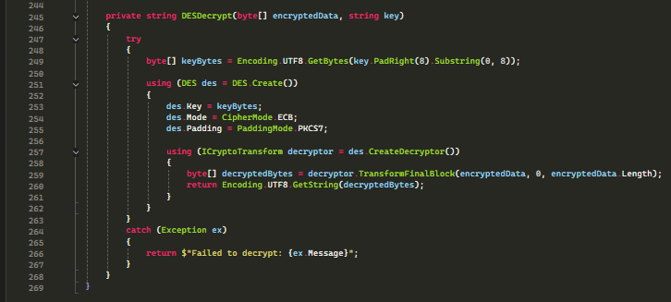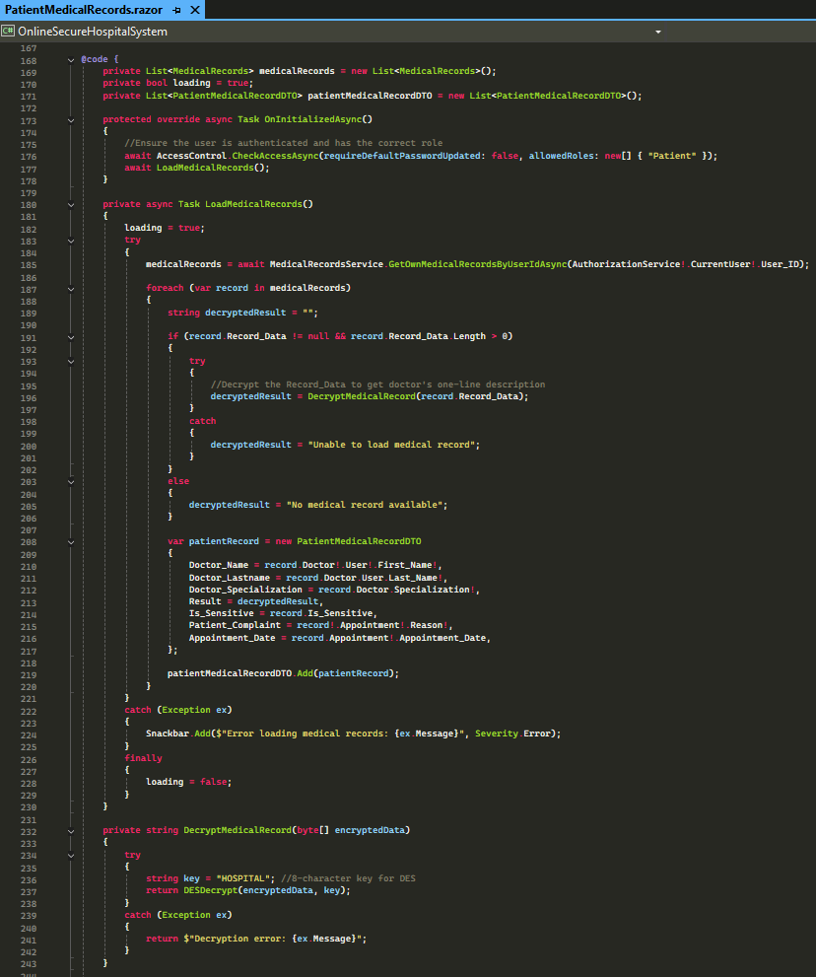

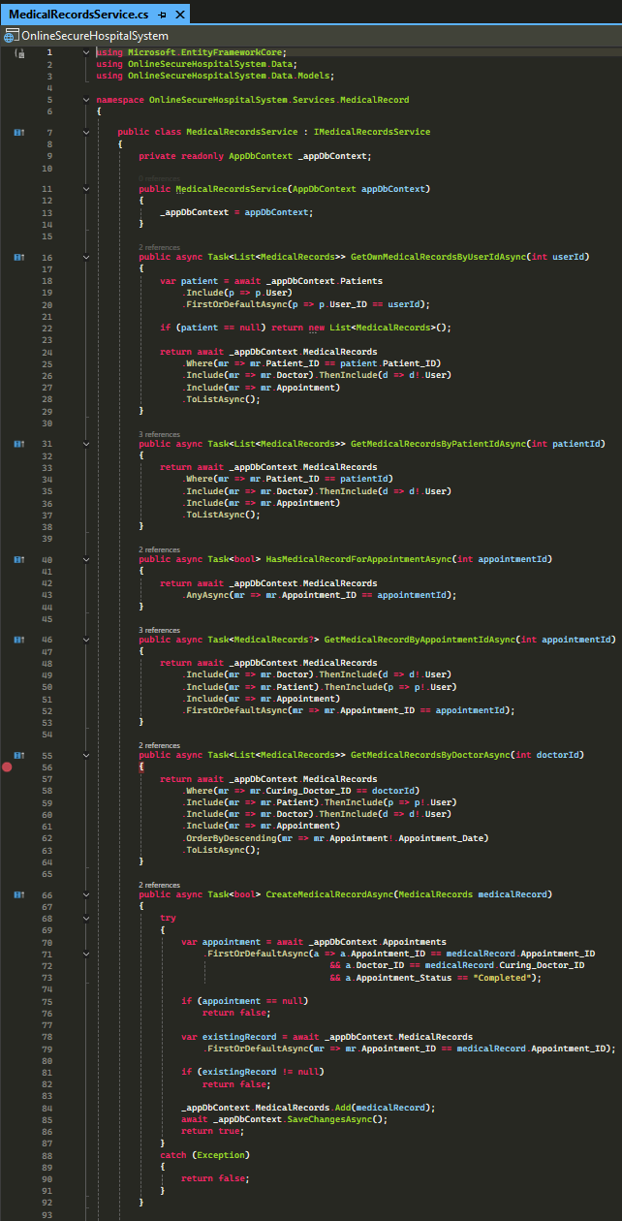

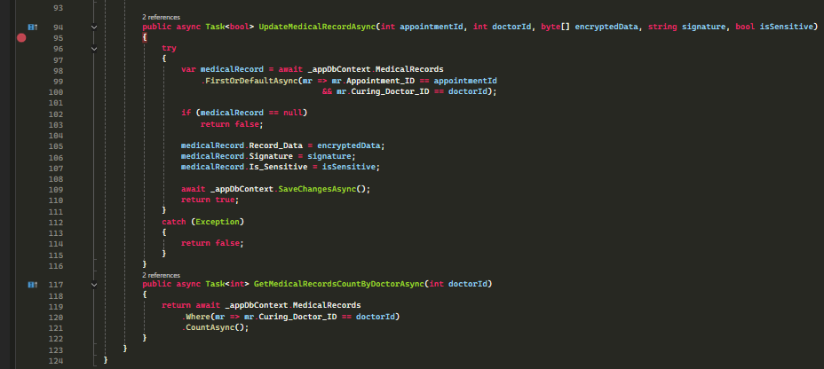

**Chief Doctor Dashboard page**

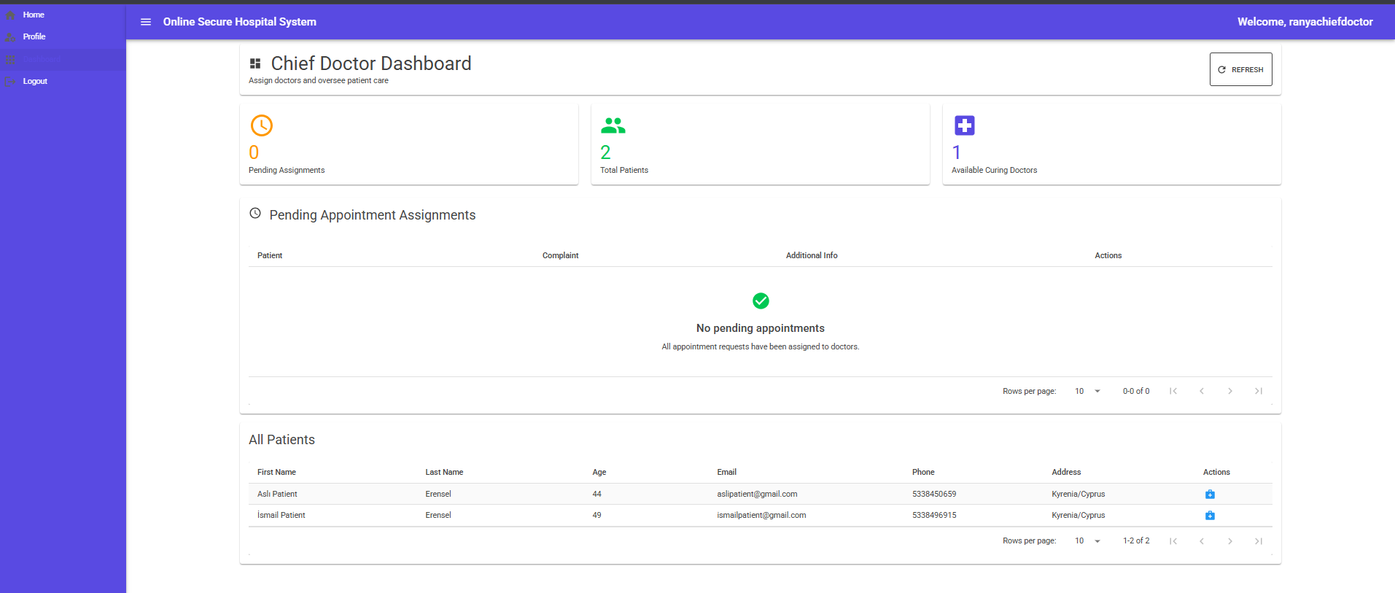Chief Doctor uses this page to view patients, stats, pending appointment requests, view medical record of patients in system. When the page is loading, logged in user role is checked and if chief doctor, menu option and the route /doctor/chief-dashboard is available to the user. DoctorService methods are used in this page. Related code material can be found in ChiefDoctorDashboard.razor file.

**Curing Doctor Dashboard Page**

Curing Doctor uses this page to view stats, pending appointments to be scheduled, scheduled appointments to make them completed and enter medical record to each patients, completed appointments to enter medical record data and see medical record data also, assigned patients to be able to assign them a consulting doctor. When the page is loading, logged in user role is checked and if curing doctor, menu option and the route /doctor/curing-dashboard is available to the user. DoctorService methods are used in this page. Related code material can be found in CuringDoctorDashboard.razor file.

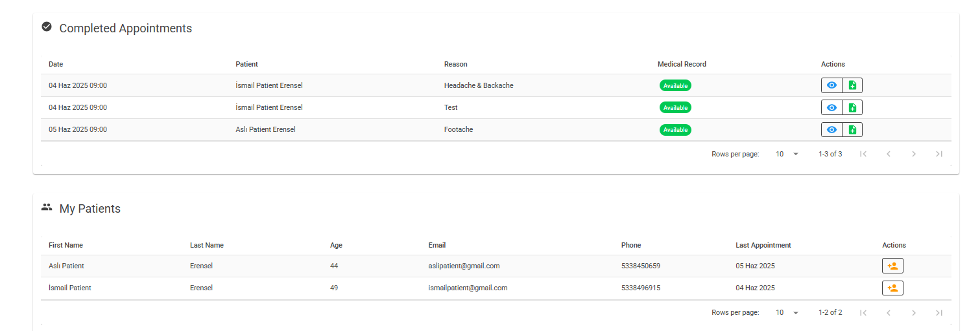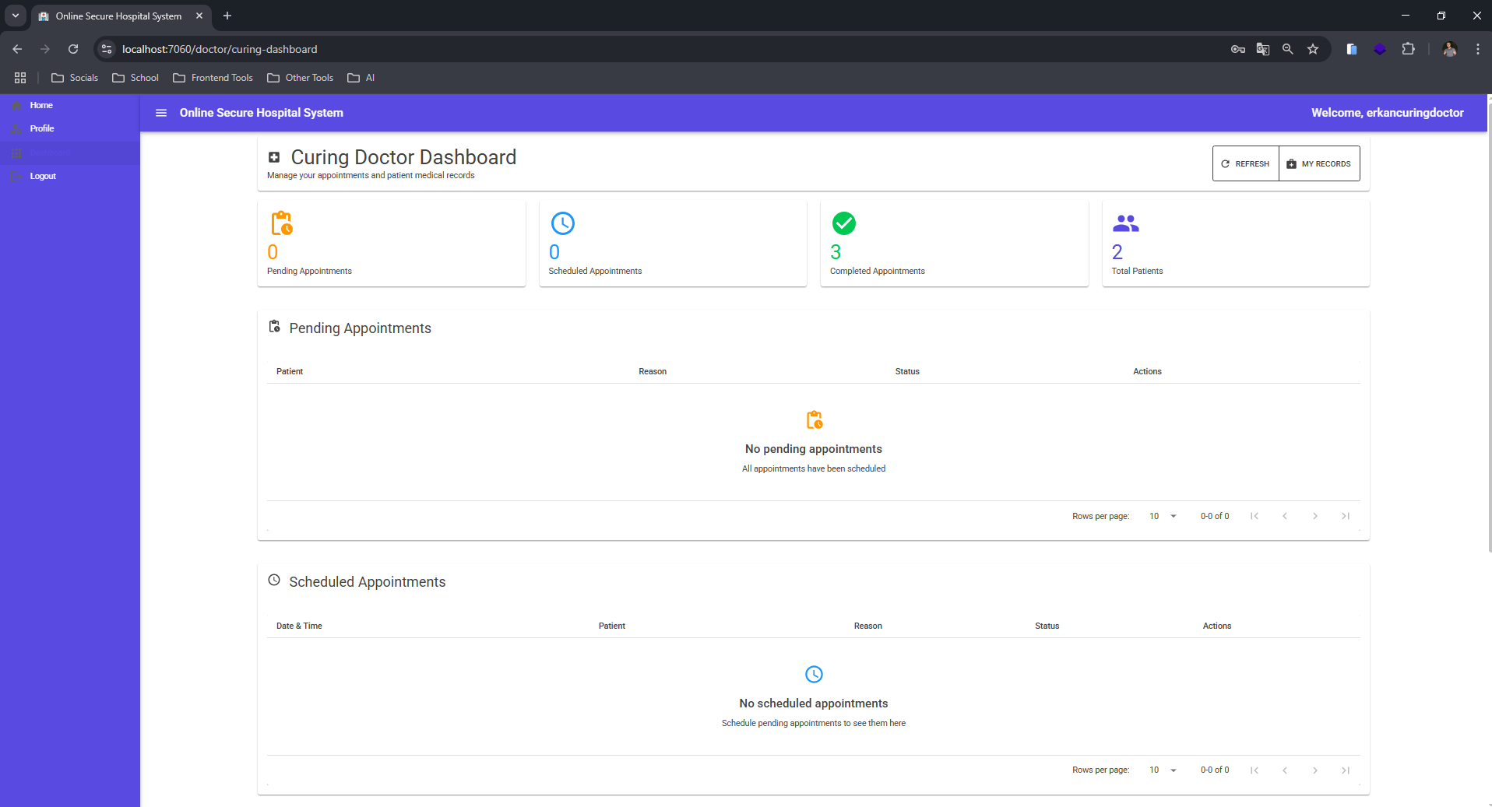

**ConsultingDoctorDashboard page**

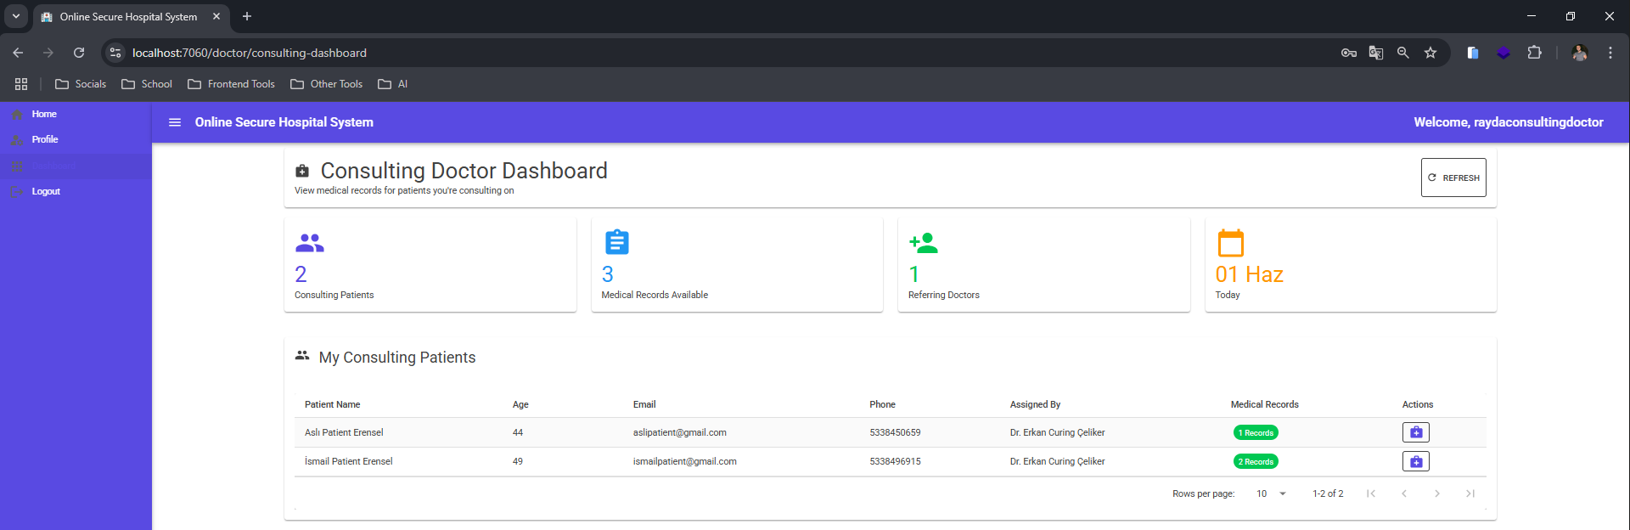Consulting Doctor uses this page to view stats, see assigned patients and their information including medical record. When the page is loading, logged in user role is checked and if consulting doctor, menu option and the route /doctor/consulting-dashboard is available to the user. DoctorService methods are used in this page. Related code material can be found in ConsultingDoctorDashboard.razor file.

**7-) User Guide**

App can be unzipped and .sln folder can be opened in Visual Studio. .NET environment should be on the computer, after this application can be launched. An admin user is created default by system to be able to login system and add other users. Credentials: username: salahiadmin, password: 123456 Admin adds 3 doctors as chief, consulting, curing, 1 receptionist. All the users need to change their default password “123456” assigned by system to be able to use the system. Receptionist logs in and registers some patients. Patients log in to their accounts and create appointment request. Chief doctor assigns the patient to a curing doctor depending on the reason of appointment (for heart reason, assign to a doctor whose specialization is heart, etc.) Curing doctor sees the appointment request and schedule an appointment with the assigned patient to a specific date and time. Appointment and assignment details are updated as scheduled. Patient can see this appointment in the appointments section. After appointment, curing doctor marks the appointment as completed and enter medical records for the patient for this appointment and can mark it as sensitive if patient shouldn’t see this record. Curing doctor can also assign this patient to a consulting doctor. Consulting doctor can see the assigned patient’s medical records.

**8-) Tests & Results**

**Login**

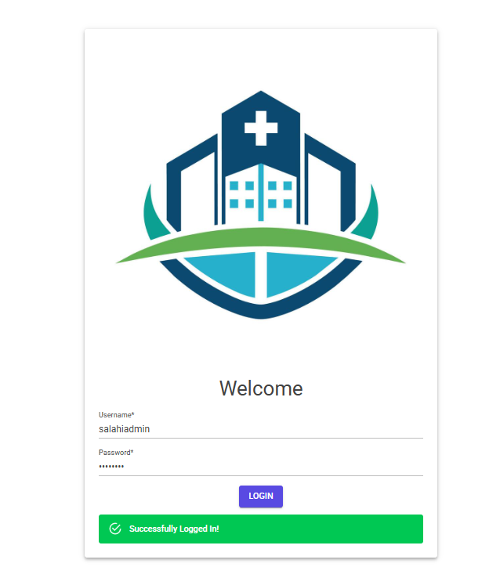

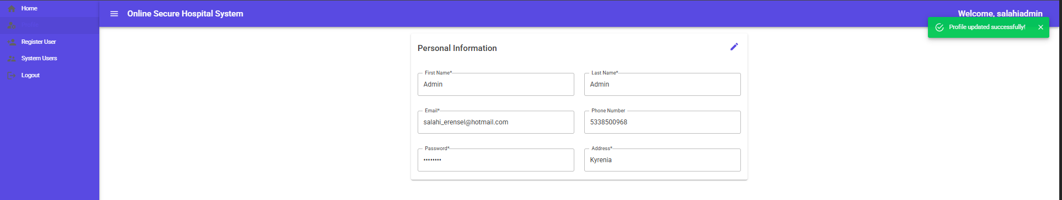**Profile Update**

**Register User Admin**

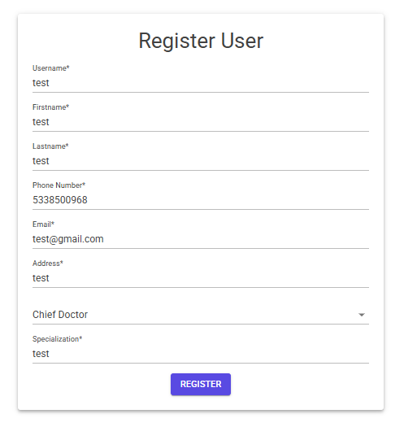

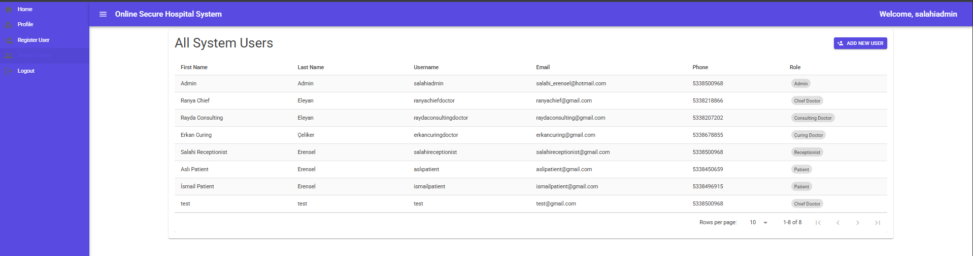**Viewing All System Users Admin**

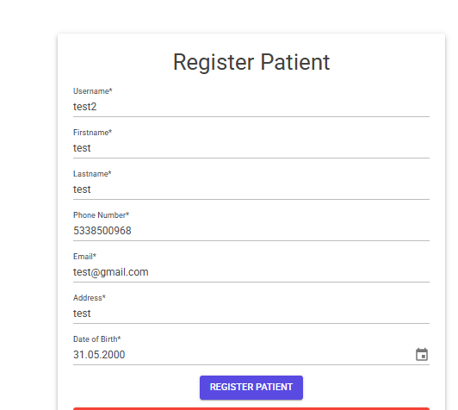**Register Patient Receptionist**

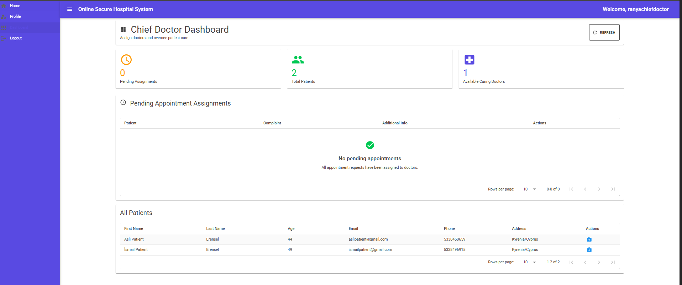**Chief Doctor Assigning Patient to Curing Doctor / Viewing Dashboard**

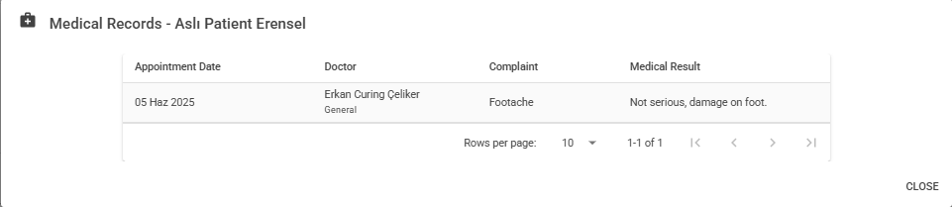**Chief Doctor Viewing Patient Medical Record**

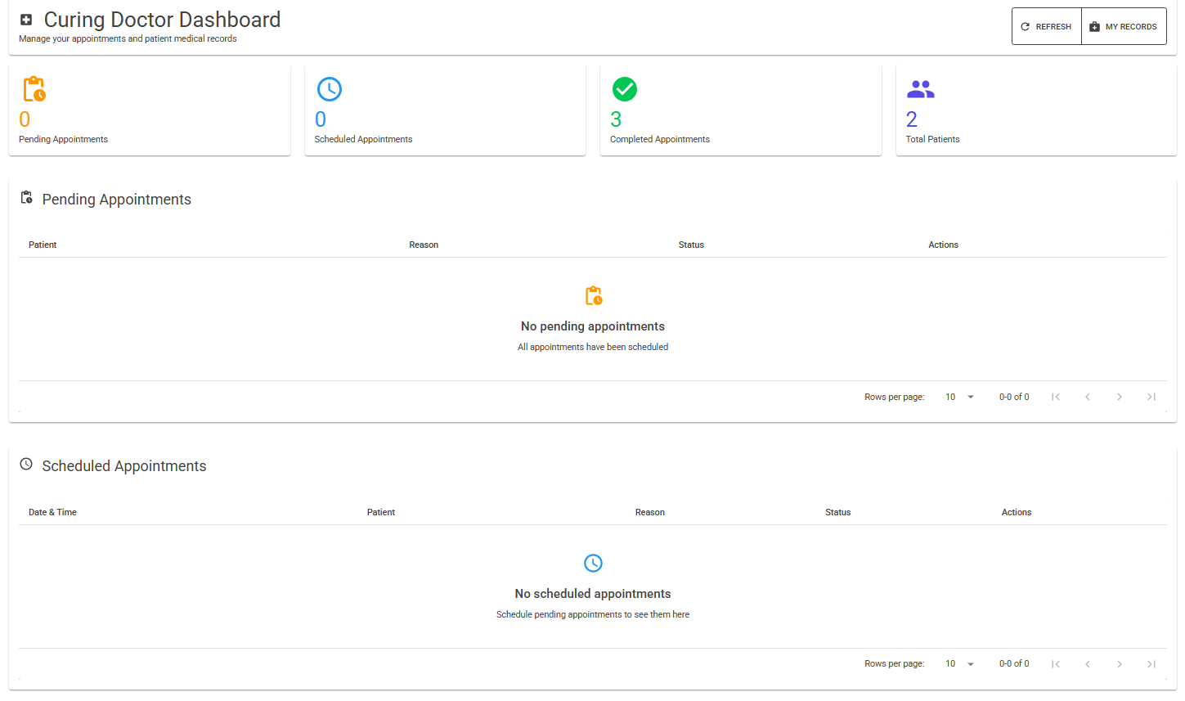**Curing Doctor Viewing Assigned Patients & Appointments**

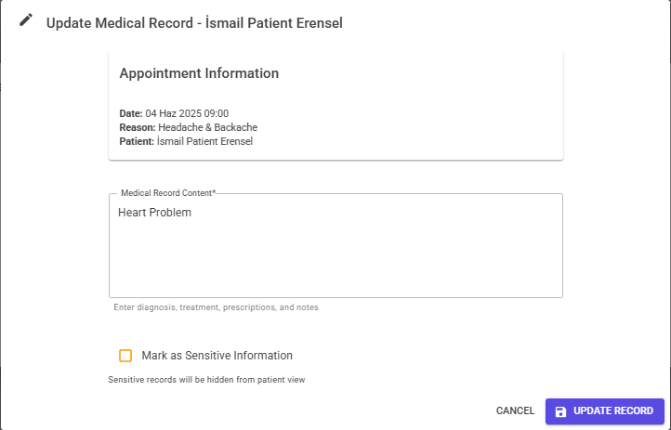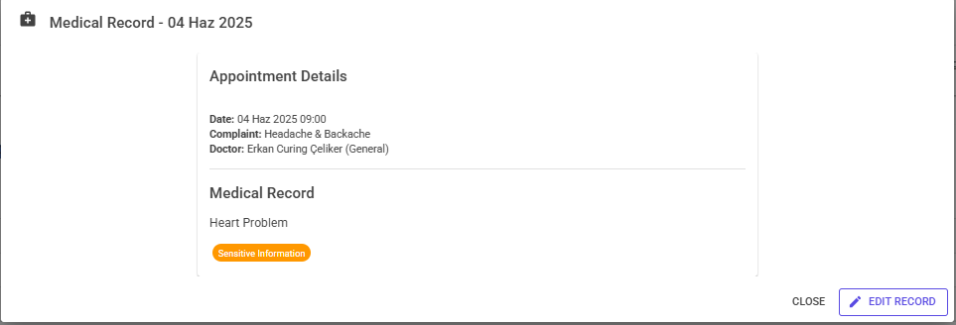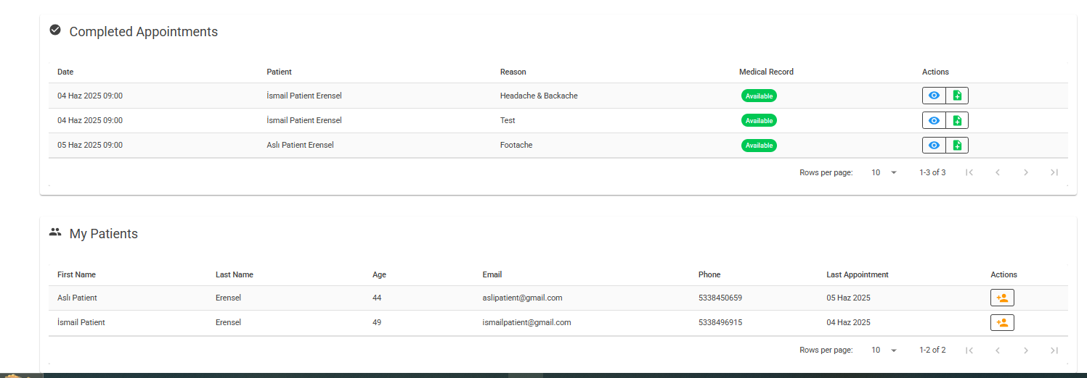**Curing Doctor Assigning Consulting Doctor to Patient & Viewing Medical Records & Adding / Updating Medical Records to Patients**

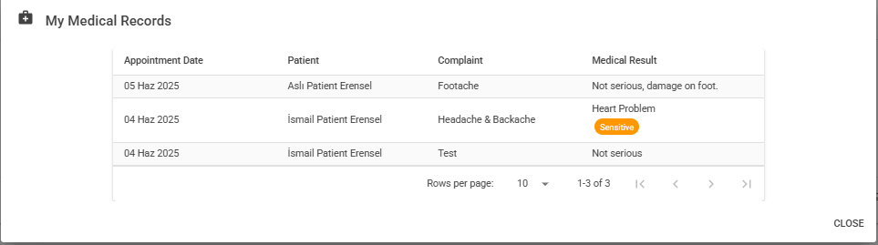

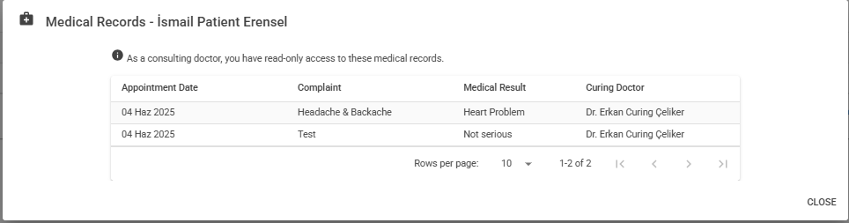**Consulting Doctor Viewing Dashboard / Assigned Patients and Medical Records**

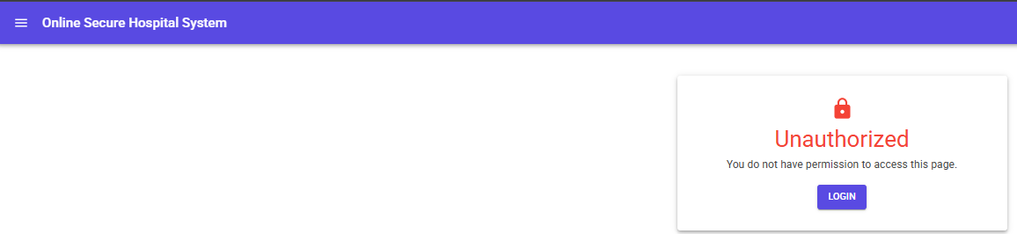**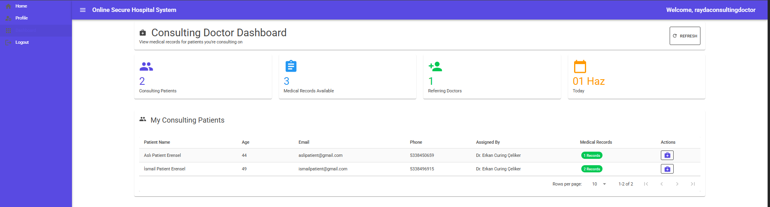Trying to reach a page without logging in or not restricted role**

**9-) Conclusion**

Maintaining high standards of patient data security, the Online Secure Hospital System offers a complete answer for modernizing hospital operations. The system guarantees sensitive medical data stays secure by using role-based access control, DES encryption, and RSA digital signatures, so allowing effective healthcare delivery.

From system managers to patients reading their medical records, the system provides different user roles with suitable permissions to meet current healthcare needs. Integration of encrypted patient record management, doctor assignment processes, and safe appointment scheduling produces a single platform that simplifies hospital operations.

By means of meticulous application of recommended algorithms and proven development tools, this system improves healthcare service delivery while preserving compliance with medical data protection criteria, so providing a strong basis for digital healthcare management.

**10-) References**

Mudblazor components <https://mudblazor.com/>

Visual studio community 2022 <https://visualstudio.microsoft.com/tr/vs/community/>

Wikipedia for encryption and digital signatures <https://en.wikipedia.org/>